1. ***What are the key features of Python?***
   * • Python is **dynamically typed**; this means that you don’t need to state the types of variables when you declare them or anything like that. You can do things like x=111 and then x="I'm a string" without error
   * • Python is well suited to [object orientated programming](https://www.edureka.co/blog/python-class/) in that it allows the definition of classes along with composition and inheritance. Python **does not have access specifiers** (like C++’s public, private).
   * • In Python, [functions](https://www.edureka.co/blog/python-functions) are first-class objects. This means that they can be assigned to variables, returned from other functions and passed into functions. Classes are also first class objects
2. ***How is Python an interpreted language?***

Python is both **compiled** as well as **interpreted** language.

In interpreted language interpreter reads a set of instructions and execute the code line by line.

In python code **first compiled** and then **interpreted**. During it compilation it converted into **.pyc** file. To reduce complexity these file gets deleted during execution process.

Why we go compilation first and then interpretation: -

We use byte code to achieve **portability**. In portability we need to write code once and run-in different machine which called **Platform Independent**. To solve these problems **virtual machine** come into the picture. In Python it is called **PVM** (Python Virtual Machine).

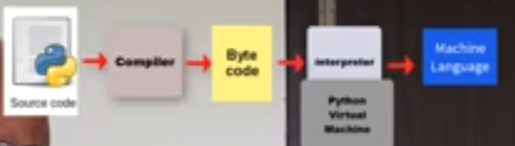

1. ***How Python Work’s?***

After installing python, we get **Interpreter** and **Library.**

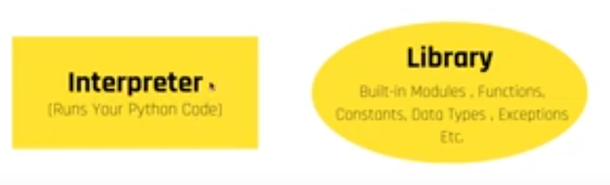

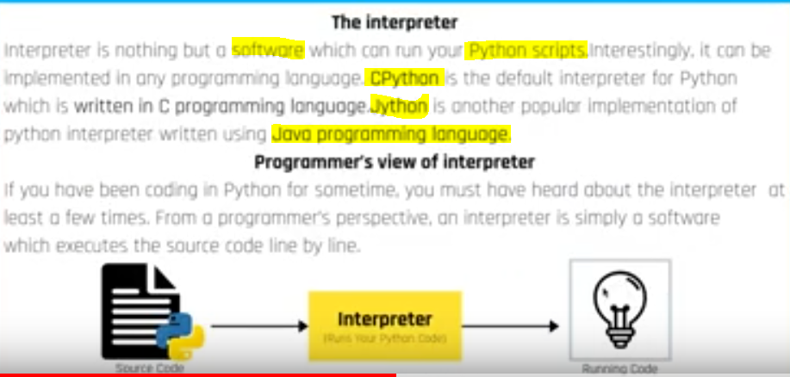

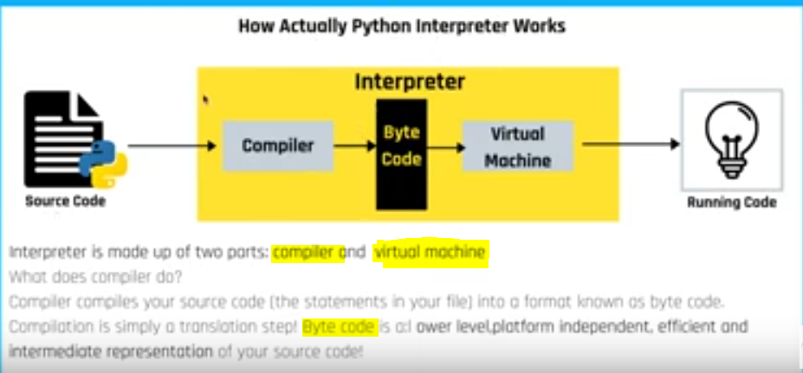

1. ***List of some Python Interpreter?***

* A compiler converts the **.py** source file into a **.pyc** bytecode for the Python virtual machine.
* A Python interpreter executes this **bytecode** on the **virtual machine**.

1. ***CPython: -*** This is the default and most widely-used implementation of Python and is written in C
2. ***Jython: -*** It runs on the **Java platform**.
3. ***IronPython***: - NET Framework and Mono and written in C#.
4. ***ActivePython***: - Active Python is a Python distribution from ActiveState. It makes installation easy and cross-platform compatibility possible
5. ***Nuitka***: - take Python code and compiles it to C/C++ executables or source code.
6. ***PyJS: -*** Use to develop client-side web and desktop applications.
7. ***Why Python is called Dynamic type?***

Data type of python variable is not defined at compile time.

1. **How is memory managed in Python?**
   * Memory management in python is managed by **Python private heap** **space**. All Python objects and data structures are located in a private heap. The programmer does not have access to this private heap. The python interpreter takes care of this instead.
   * The allocation of heap space for Python objects is done by **Python’s memory manager.** The core API gives access to some tools for the programmer to code.
   * Python also has an **inbuilt** garbage collector, which recycles all the unused memory and so that it can be made available to the heap space.

How much **memory is allocated** depend on Python version, Platform and Environment settings.

Python Memory is divided into two parts: -

1. Heap Memory
2. Stack Memory
3. ***Key Differences Between Stack and Heap Allocations?***
4. In a **stack**, the allocation and deallocation is **automatically** done by whereas, in **heap**, it needs to be done by the programmer **manually**.
5. Handling of **Heap frame is costlier** than handling of stack frame.
6. **Memory shortage** problem is more likely to happen in **stack** whereas the main issue in **heap** memory is **fragmentation**.
7. **Stack** frame access is **easier** than the heap frame as the stack have small region of memory and is cache friendly, but in case of heap frames which are dispersed throughout the memory so it causes more cache misses.
8. **Stack** is not **flexible**, the memory size allotted cannot be changed whereas a heap is flexible, and the allotted memory can be altered.
9. **Accessing time** of **heap** takes is **more** than a stack.
10. ***What is PYTHONPATH?***
    * It is an **environment** variable which is used when a module is imported. Whenever a module is imported, PYTHONPATH is also looked up to check for the **presence of the imported modules in various directories**. The interpreter uses it to determine which module to load.
11. ***What are python modules? Name some commonly used built-in modules in Python?***

Python modules are files containing Python code. This code can either be **functions** **classes** or **variables**. A Python module is a .py file containing **executable code**.

Some of the commonly used built-in modules are:

* os
* sys
* math
* random
* data time
* JSON

1. ***.What are local variables and global variables in Python?***

**Global Variables:**

Variables declared outside a function or in global space are called global variables. These variables can be accessed by any function in the program.

**Local Variables:**

Any variable declared inside a function is known as a local variable. This variable is present in the local space and not in the global space.

**Example:**

a=**2**def add():  
 b=**3** c=a+b  
 print(c)  
add()

**Output:**5

When you try to access the local variable outside the function add(), it will throw an error.

1. ***Is python case sensitive?***

***Yes.***

1. ***Python string function?***

***Immutable: - Elements of the string cannot be changed once it has assigned.***

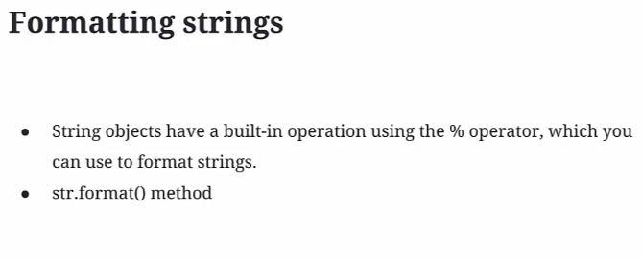

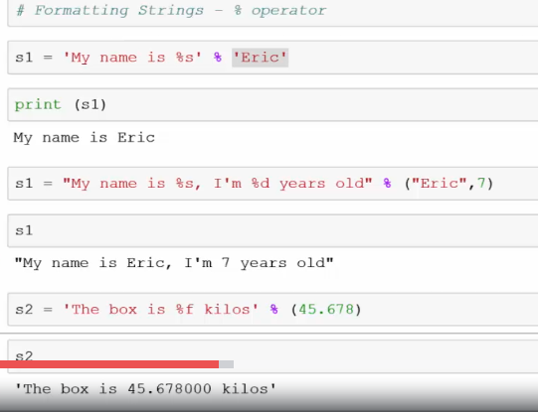

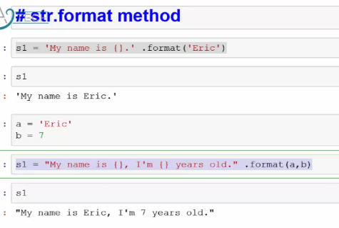

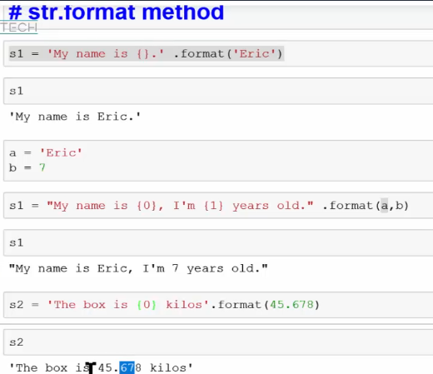

Exercise:-

# Reverse a String  
  
x = input("Please enter a string")   
print(x[::-**1**])

# Count the words and characters  
x = "abcdefg"  
print(len(x))

# Return part of the input string  
x = "Happiness"  
y = (len(x) - **2**) // **2**z = (len(x) + **3**) // **2**

# Return string with maximum length  
x = input('Please enter first string')  
y = input('Please enter second string')  
if len(x) > len(y):  
 print(x)  
elif len(x) < len(y):  
 print(y)  
else:  
 print("x is {0}, y is {1}".format(x**,** y))

print(x[y:z])

1. ***List?***

* Lists are **mutable or Editable**.
* Every item in a list can called individually, through **indexing**.
* **Slicing** can be performed to extract part of a list.
* Syntax: list_1 = [10, ‘Chelsea’, 20]

*How list elements are stored into memory:*

Each list contain the memory address of its element.

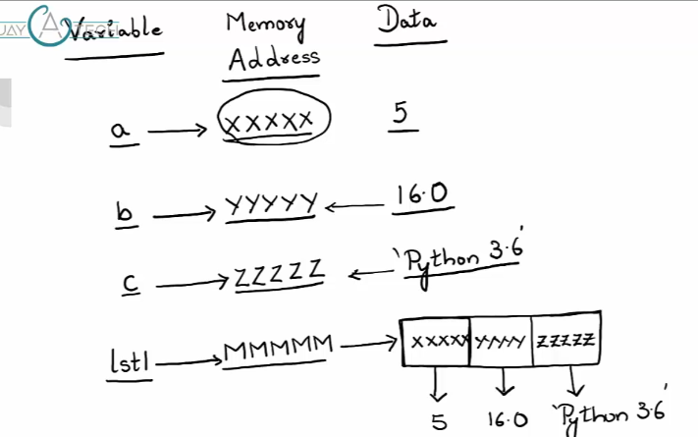

*Lists are mutable:*

Once list created, they can be modified by adding, deleting and changing elements in the list.

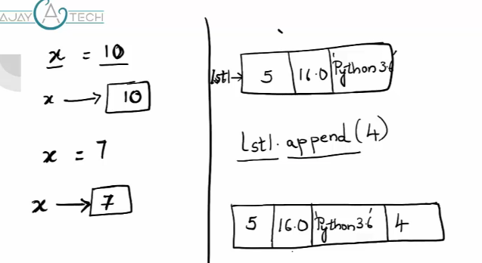

After append new elements into the list memory address is **not changed.**

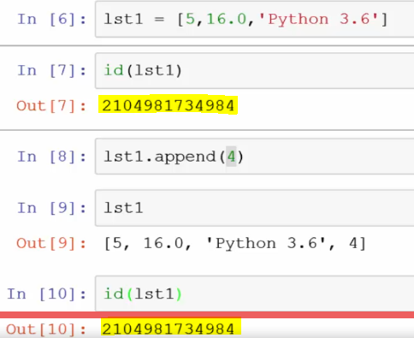

*Accessing individual elements into a list through indexing:*

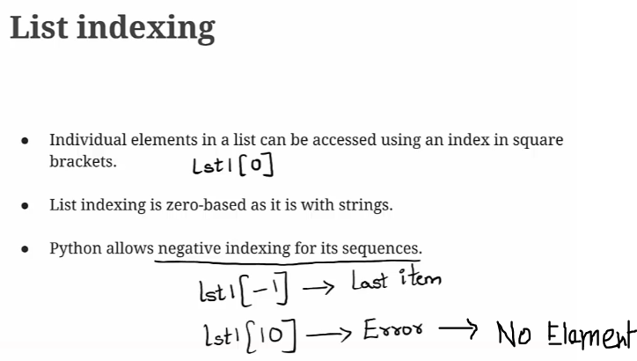

*List Slicing:*

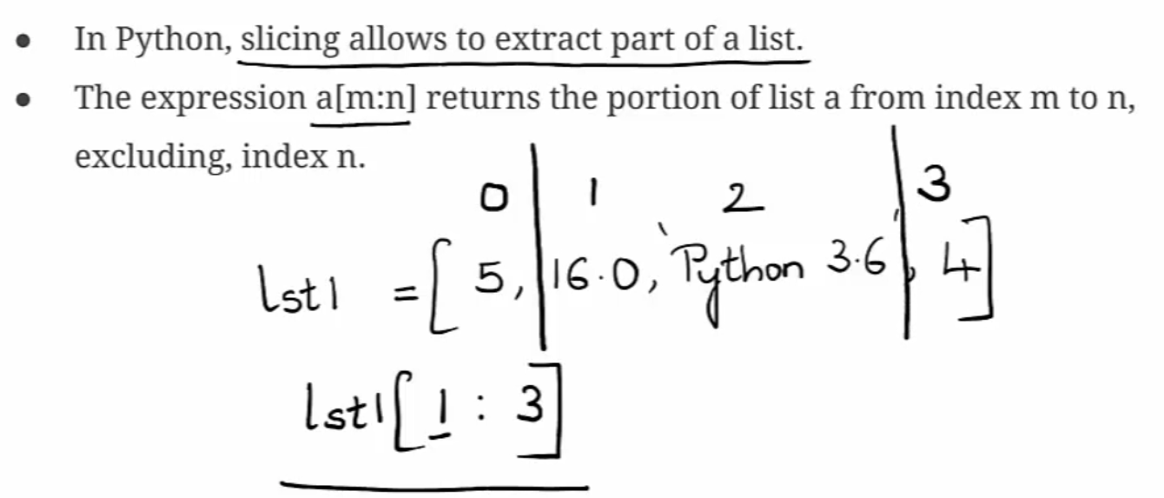

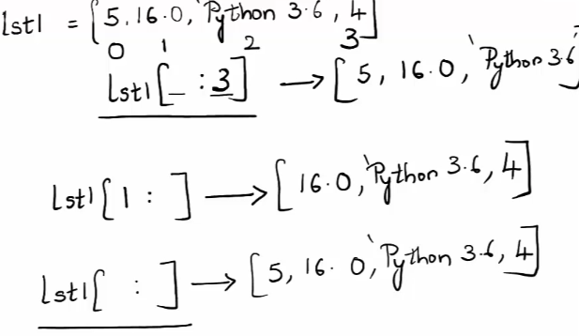

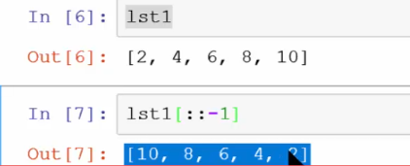

*List Comprehension:*

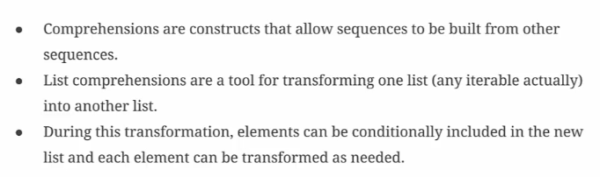

l1 = [**1, 2, 3, 4, 5, 6, 7**]  
l2 = [x for x in l1]  
print(l2)

# l2 contain square root of al elements in l1  
l2 = [(x ** **2**) for x in l1]  
print(l2)

# l2 contain square root of al elements in l1 if element > 3  
l2 = [(x ** **2**) for x in l1 if x > **3**]  
print(l2)

Output: [1, 2, 3, 4, 5, 6, 7]

[1, 4, 9, 16, 25, 36, 49]

[16, 25, 36, 49]

*List() Constructor:*

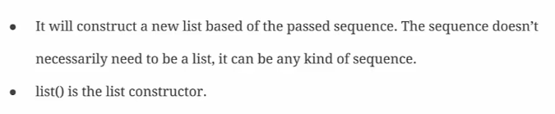

# list() constructor  
lc = list([**3, 5, 7, 9**])  
lc = list("PYTHON")  
print(lc)

Output: [16, 25, 36, 49]

['P', 'Y', 'T', 'H', 'O', 'N']

*List Methods*

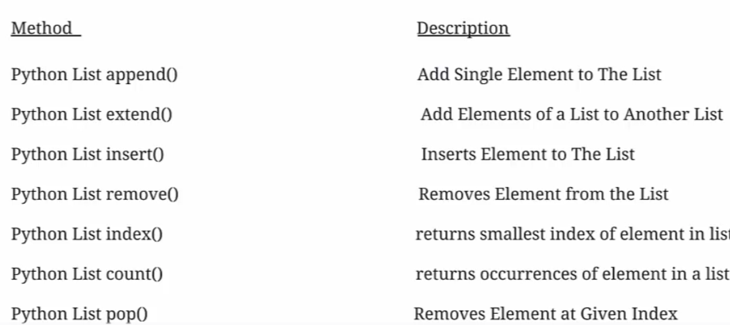

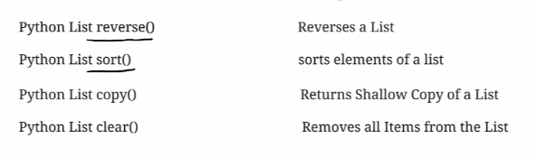

* *Difference between list.append() and list.extend():-*

It append entire list to the existing list as single item.

append() takes the arguments on it takes as **single item**.

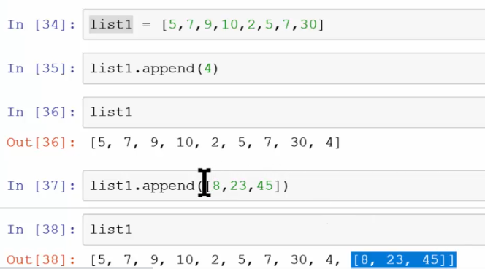

extend() can add each of the item **individually** to the existing list.

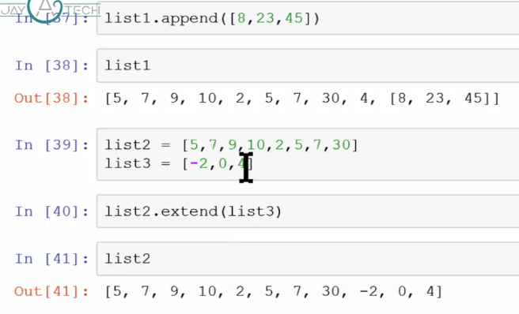

Insert() – insert an item into the list with specific index.-7 added to the index 3 position.

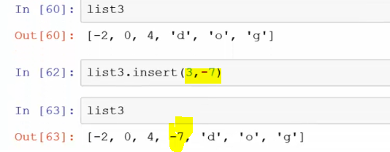

Index():- return index of the specific element.

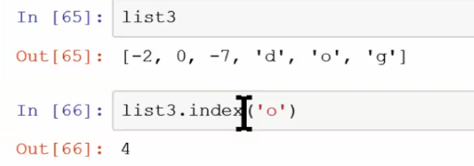

Copy():-

It copy entire list element to another list but it **does not refer same memory address.**

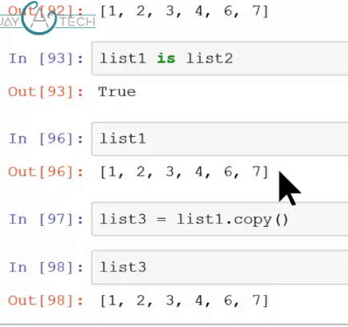

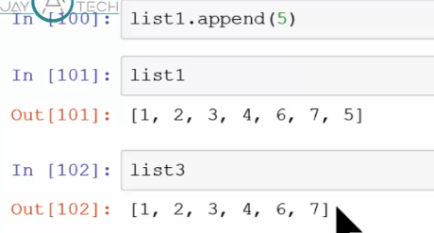

* *Convert list to join:-*

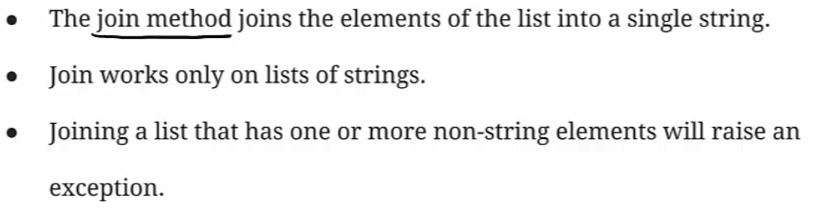

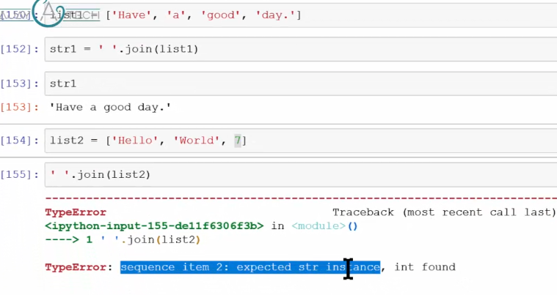

* *Nested Lists:-*

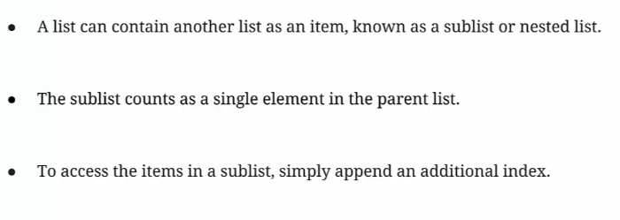

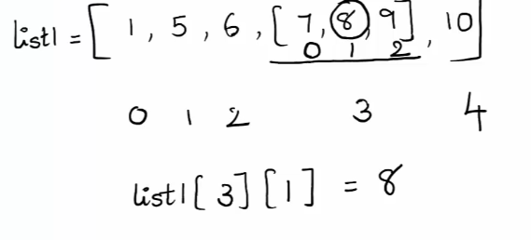

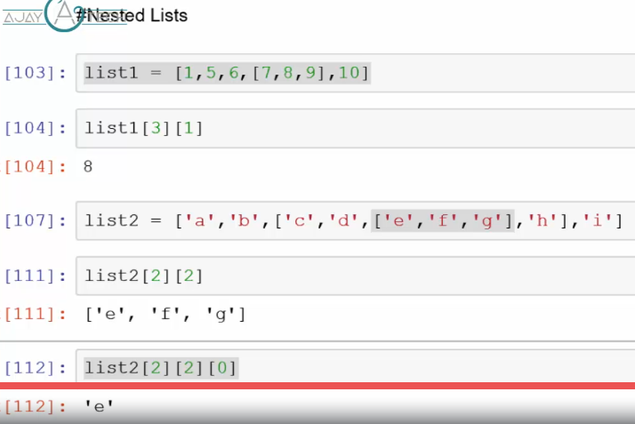

* *Aliasing and cloning Lists:-*

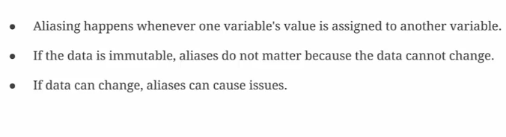

*They refer to same memory address.*

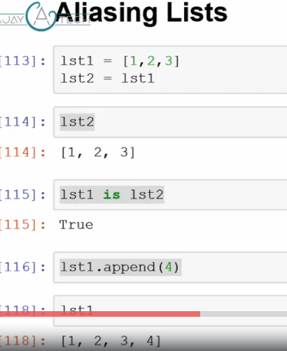

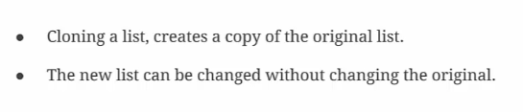

*They refer to different memory address.*

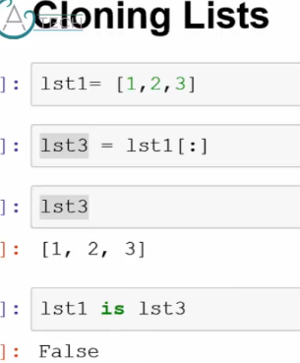

*Exercise:*

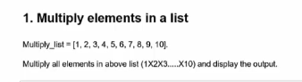

# Multiply elements of a list  
  
multiply_list = [**1, 2, 3, 4, 5, 6, 7, 8, 9, 10**]  
result = **1**for x in multiply_list:  
 result = result * x  
  
print(result)

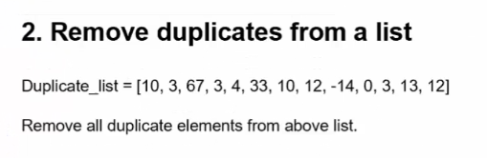

# Remove duplicate from list  
duplicate_list = [**10, 3, 67, 3, 4, 33, 10, 12,** -**14, 0, 3, 13, 12**]  
l1 = list(set(duplicate_list))  
l1.sort()  
print(l1)

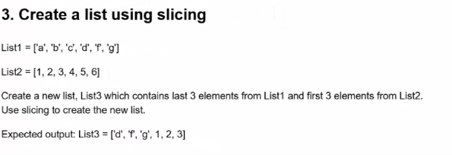

# Create a list using slicing  
  
List1 = ['a'**,** 'b'**,** 'c'**,** 'd'**,** 'f'**,** 'g']  
List2 = [**1, 2, 3, 4, 5**]  
List1 = List1[**3**:]  
List2 = List2[-**3:**]  
List3 = List1 + List2  
print(List3)

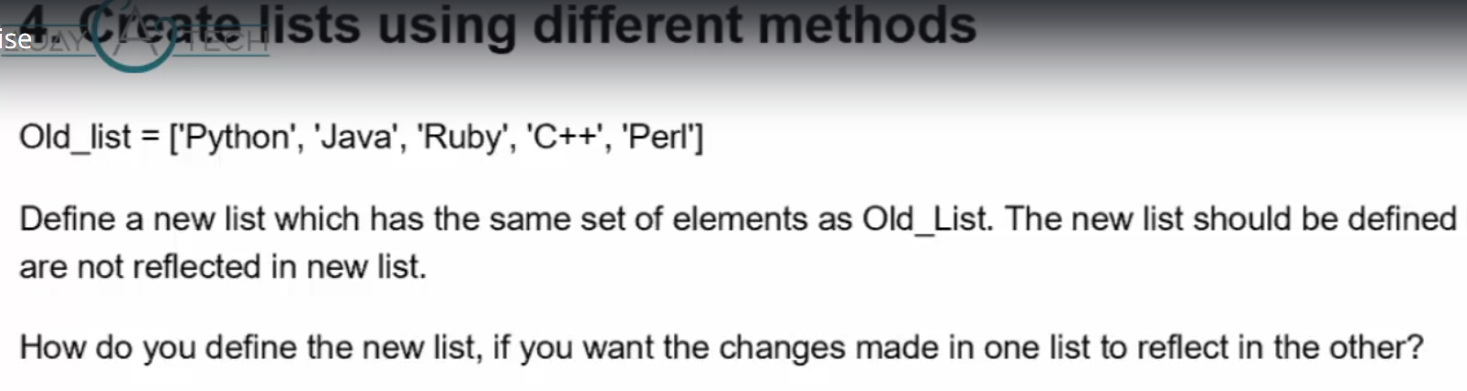

# Create lists using different method  
Old_list = ['Python'**,**'Java'**,** 'Ruby'**,** 'C++'**,** 'Perl']  
New_list = Old_list.copy()  
New_list.append('Dot Net')  
print(New_list)  
print(Old_list)

Old_list = ['Python'**,**'Java'**,** 'Ruby'**,** 'C++'**,** 'Perl']  
New_list = Old_list  
New_list.append('Dot Net')  
print(New_list)  
print(Old_list)

['Python', 'Java', 'Ruby', 'C++', 'Perl', 'Dot Net']

['Python', 'Java', 'Ruby', 'C++', 'Perl']

['Python', 'Java', 'Ruby', 'C++', 'Perl', 'Dot Net']

['Python', 'Java', 'Ruby', 'C++', 'Perl', 'Dot Net']

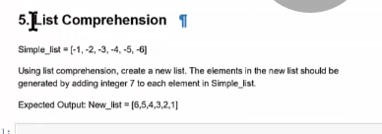

# List Comprehension  
Simple_list = [-**1,**-**2,**-**3,**-**4,**-**5,**-**6**]  
New_list = [x+**7** for x in Simple_list]  
print(New_list)

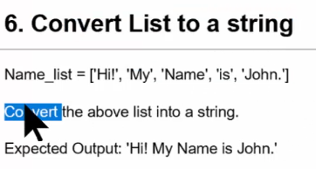

# Convert list to string  
Name_list = ['Hi'**,** 'My'**,** 'Name'**,** 'is'**,** 'John']  
l1 = ' '.join(Name_list)  
print(l1)

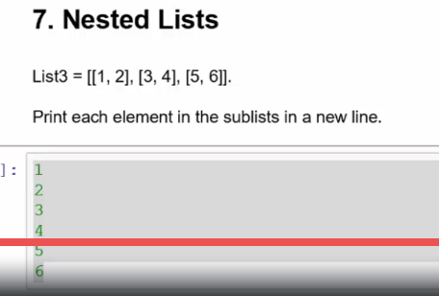

1. ***Dictionary?***

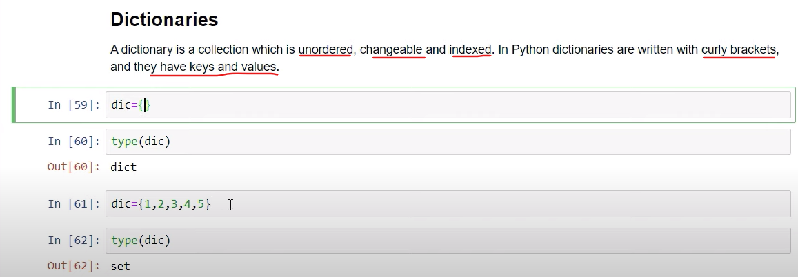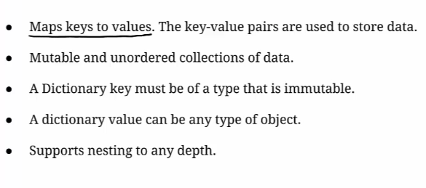

***Dictionary***

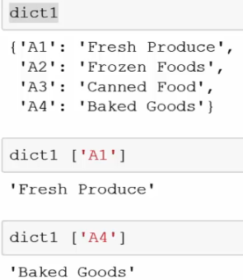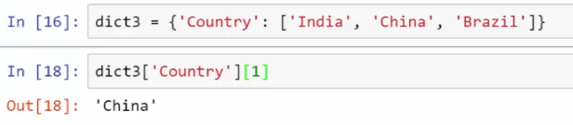

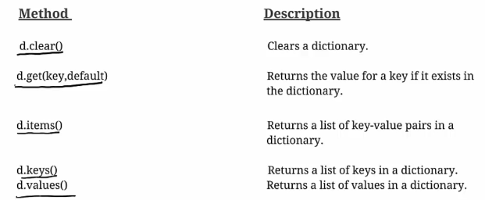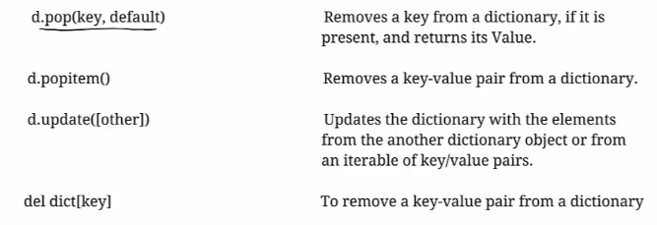

* *Get():-*

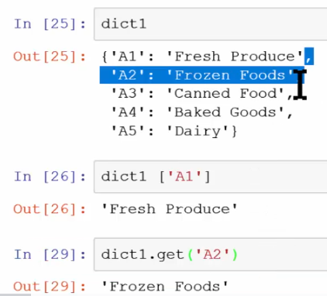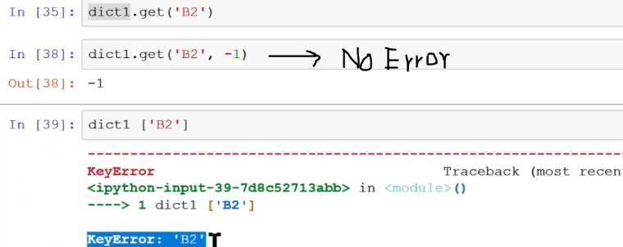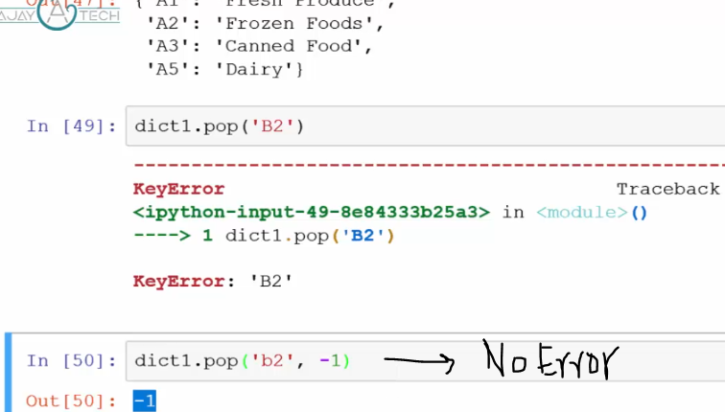

* *Looping item in dictionary: -*

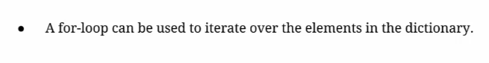

*Display Keys:*

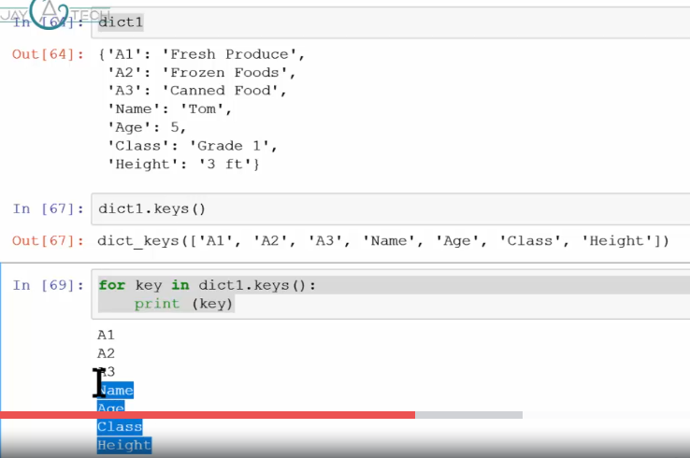

*Display Key value pair:*

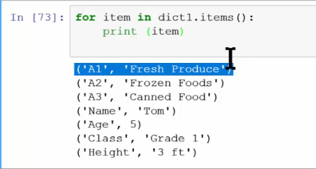

* *Dictionary Comprehension:-*

Dictionary comprehension is a method for **transforming** one dictionary into another dictionary. During this transformation, items within the original dictionary can be **conditionally** included in the new dictionary and each item can be **transformed** as needed.

*Advantage:-*

Dictionary comprehension is a powerful concept and can be used to **substitute** for **loops** and **lambda** functions. However, not all for loop can be written as a dictionary comprehension but all dictionary comprehension can be written with a for loop.

Exercise:

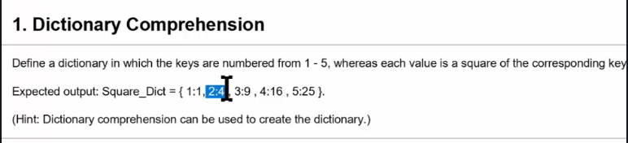

# Dictionary comprehension  
Square_Dict = {k: k * k for k in [**1, 2, 3, 4, 5**]}  
print(Square_Dict)

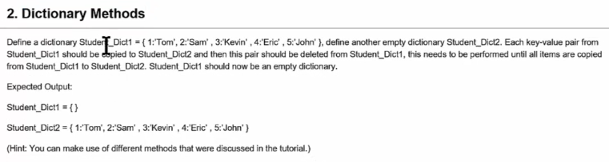

# Dictionary methods  
Studnet_Dict1 = {**1**:'Tom'**,2**:'Sam'**,3**:'Kevin'**,4**:'Eric'**,5**:'John'}  
Studnet_Dict2 = {}  
for item in Studnet_Dict1.items():  
 Studnet_Dict2.update([item])  
   
Studnet_Dict1.clear()  
print(Studnet_Dict1)  
print(Studnet_Dict2)

1. ***Tuple?***

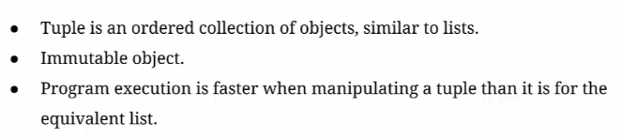

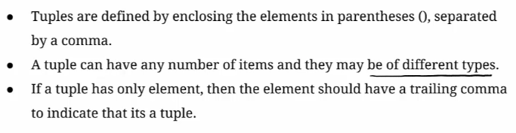

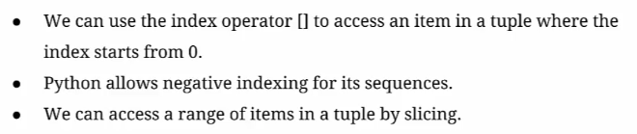

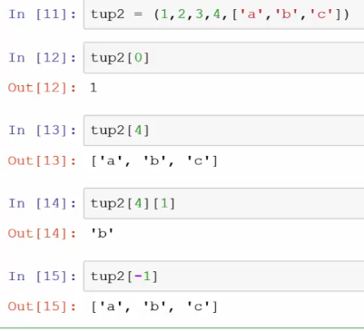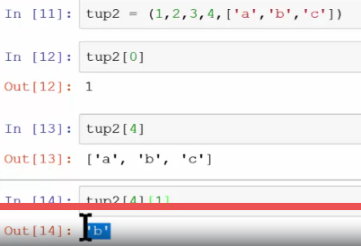  
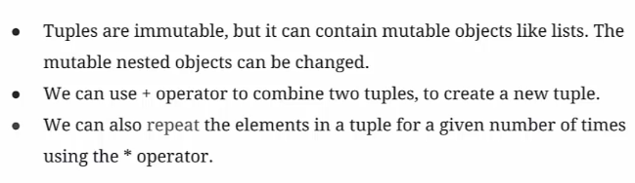

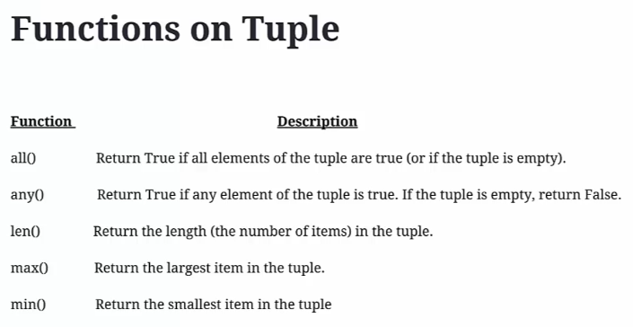

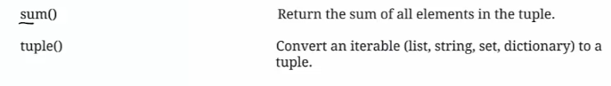

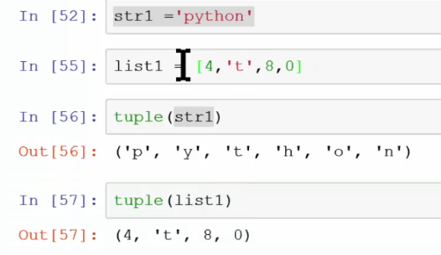

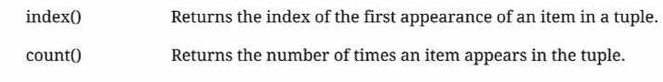

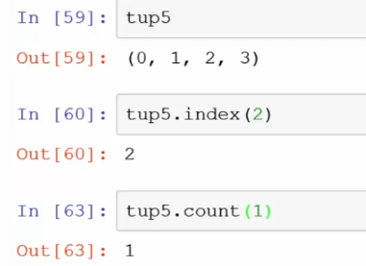

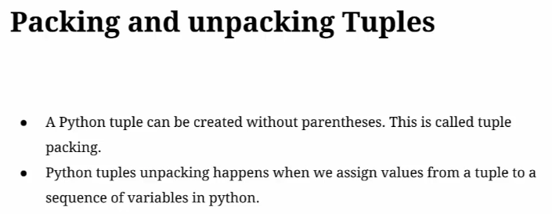

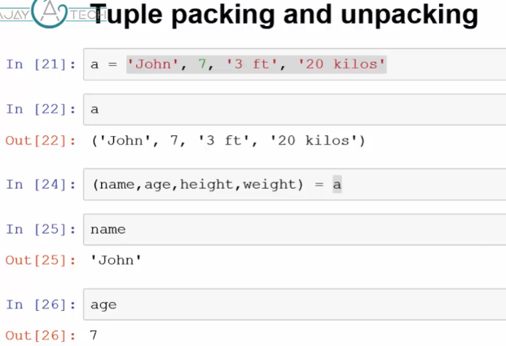

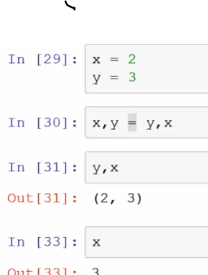

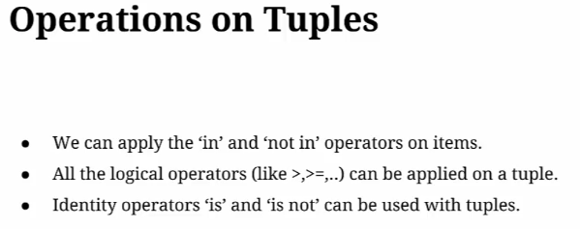

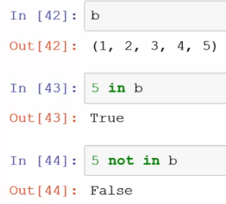

Exercise:

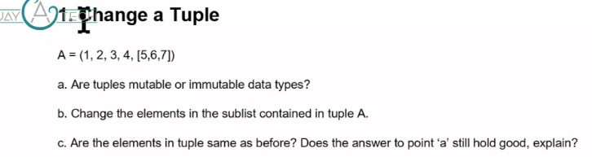

* + 1. Tuple is immutable but it holds mutable object like list which is changeable.
* # Change a tuple  
  A = (**1, 2, 3, 4,** [**5, 6, 7**])  
  print(A[**4**])  
  print(id(A))  
  print(id(A[**4**]))  
  A[**4**][**0**] = **8**A[**4**][**1**] = **9**print(A[**4**])  
  print(id(A))  
  print(id(A[**4**]))

[5, 6, 7]

1819350427080

1819350360712

[8, 9, 7]

1819350427080

1819350360712

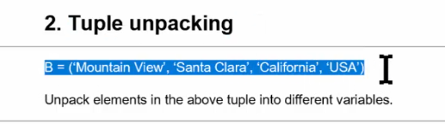

# Tuple Unpacking  
B = 'Mountain View'**,** 'Santa Clara'**,** 'California'**,** 'USA'  
print(B)  
(Name**,** Place**,** State**,** Country) = B  
print(Name + ' is situated at ' +Place+' in the state of '+State+','+Country )

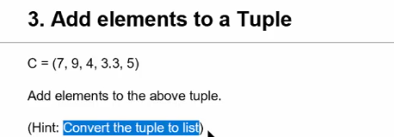

# Add element to tuple  
C = (**7,9,4,3,3,5**)  
C = list(C)  
print(type(C))  
C.append(**6**)  
C.insert(**2,17**)  
C = tuple(C)  
print(type(C))  
print(C)

Output:-

<class 'list'>

<class 'tuple'>

(7, 9, 17, 4, 3, 3, 5, 6)

1. ***Sets?***

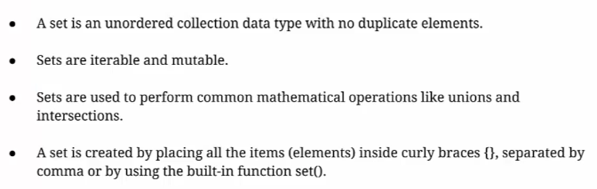

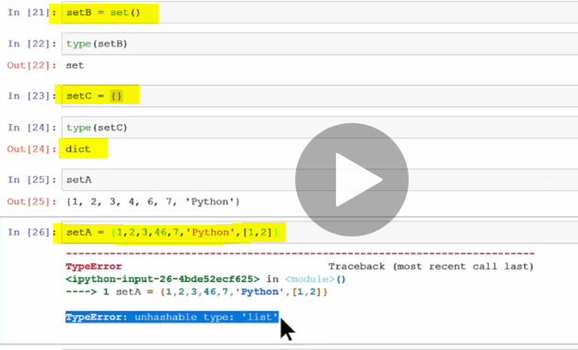

* Set does not have any mutable data type like list in it.
* It **does not support indexing**.

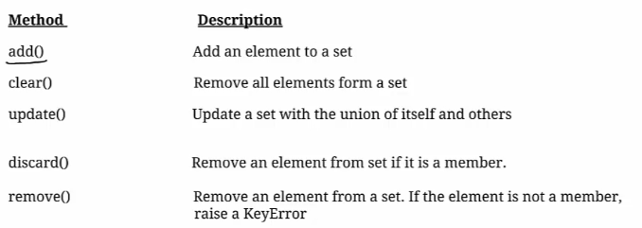

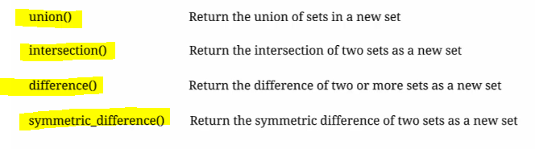

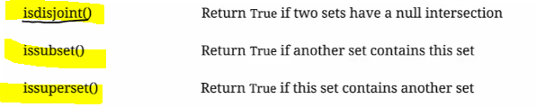



Add():

As set is unordered collection so

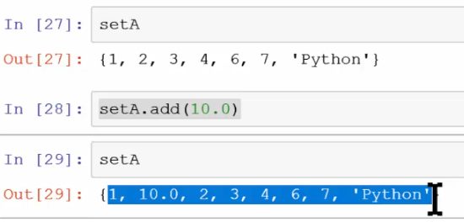

Update():

It update only unique element to the set.

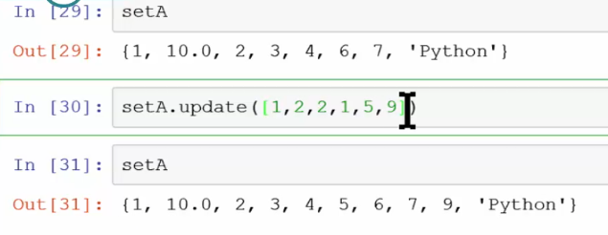

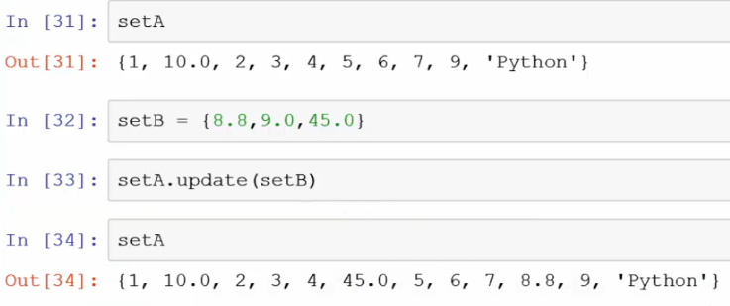

* *Difference between discard() & remove():-*

If any element does not exist in a set then **remove** will throw an exception.

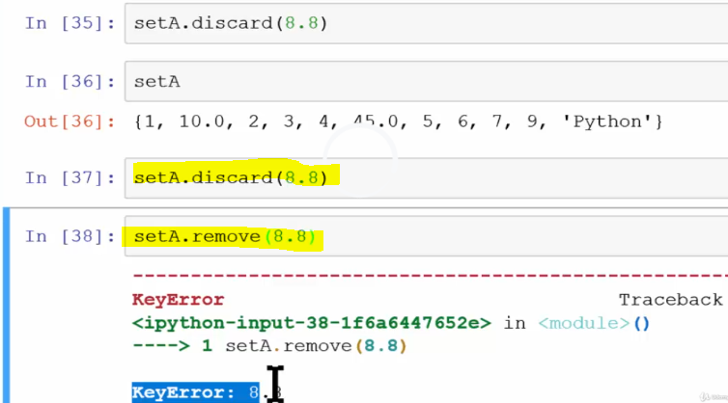

Pop():-

Remove a random item from a set.

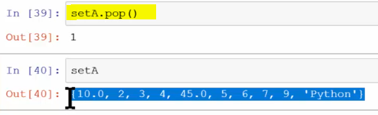

**Union():-**

Return all values from both the sets except duplicate.

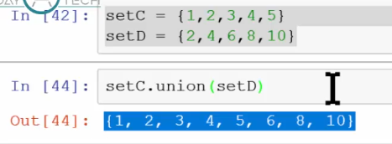

**Intersection ():-**

Return only common elements from both of the sets.

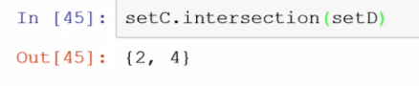

**Difference ():-**

**Return only the elements present in the set C.**

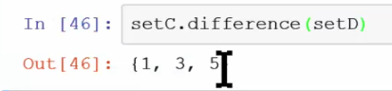

**Symmetric_difference ():-**

Retrieve value from two set except common values.

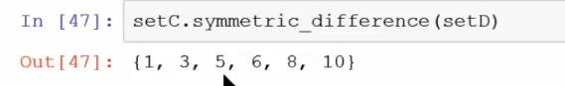

**isdisjoint():-** if both sets are unique return true else false.

**issubset():-** if both set contain same element return true else false.

**Isupperset():**- as element present in the set so return true.

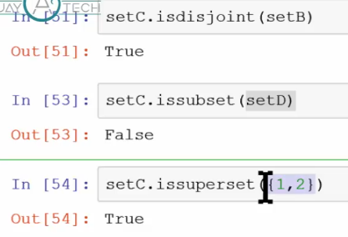

Sorted():-

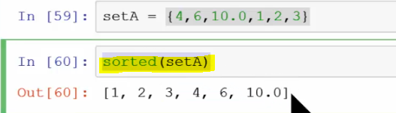

Exercise:

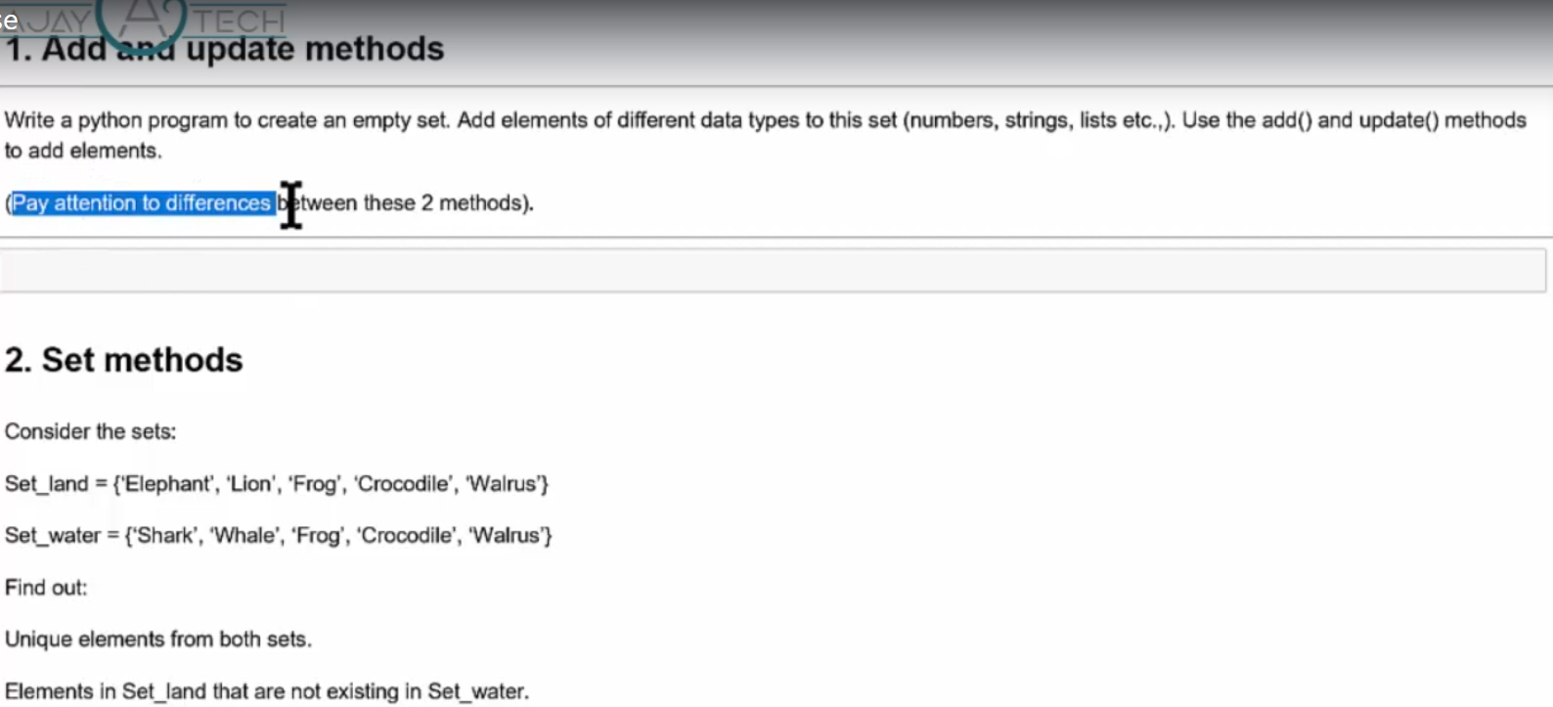

1. ***Conditional or Control flow Statement?***

IF Statement:

Exercise:

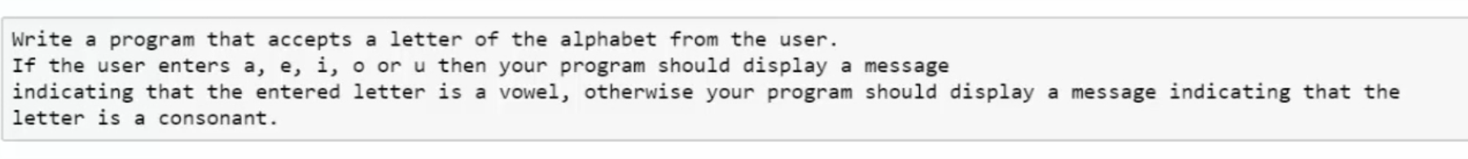

# Check letter  
a = input('Please enter a letter \n')  
vowel_list = ['a'**,** 'e'**,** 'i'**,** 'o'**,** 'u']  
if a in vowel_list:  
 print('letter is vowel')  
else:  
 print('letter is consonant')

sides')

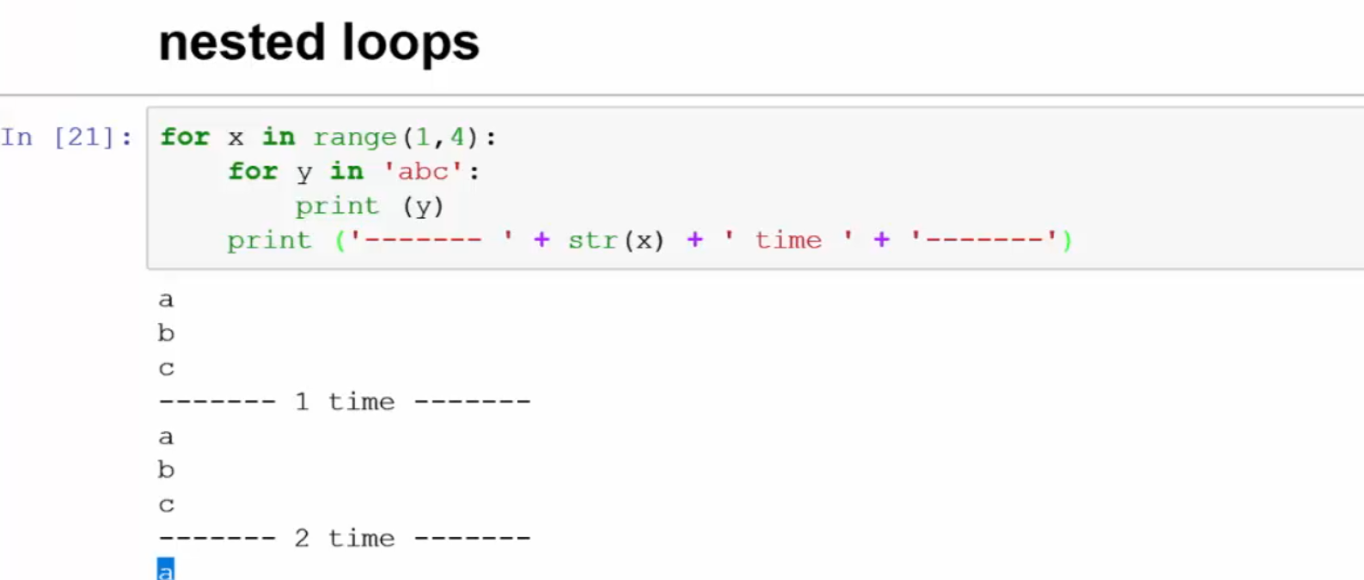

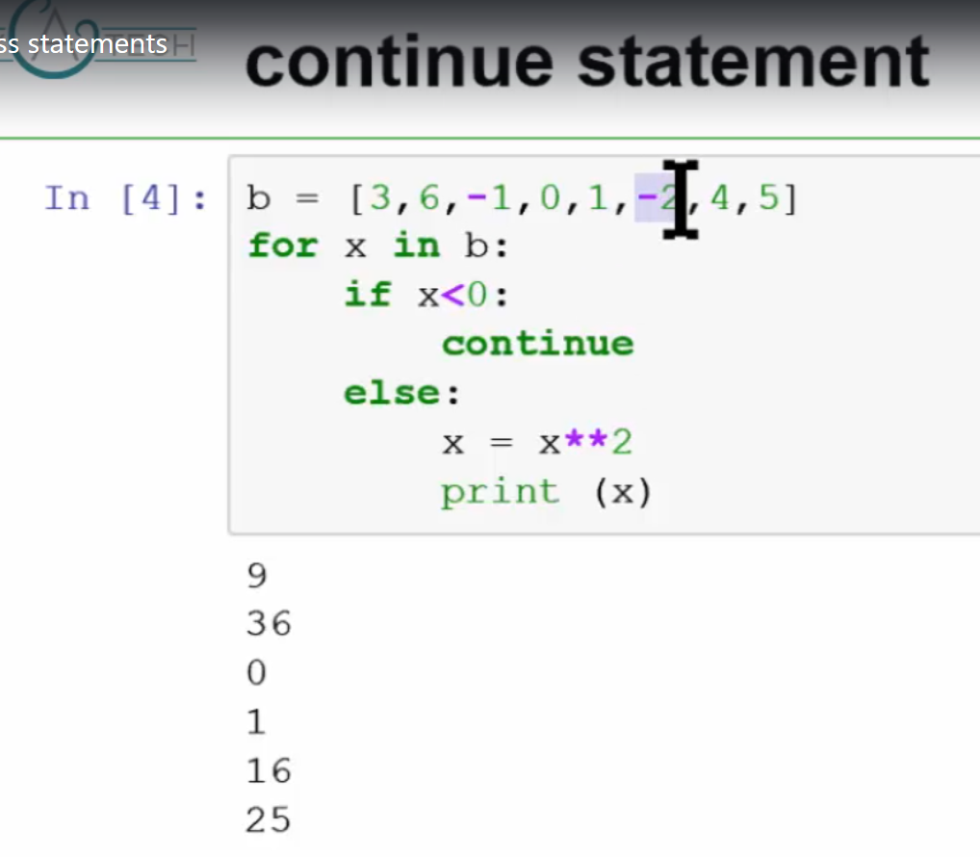

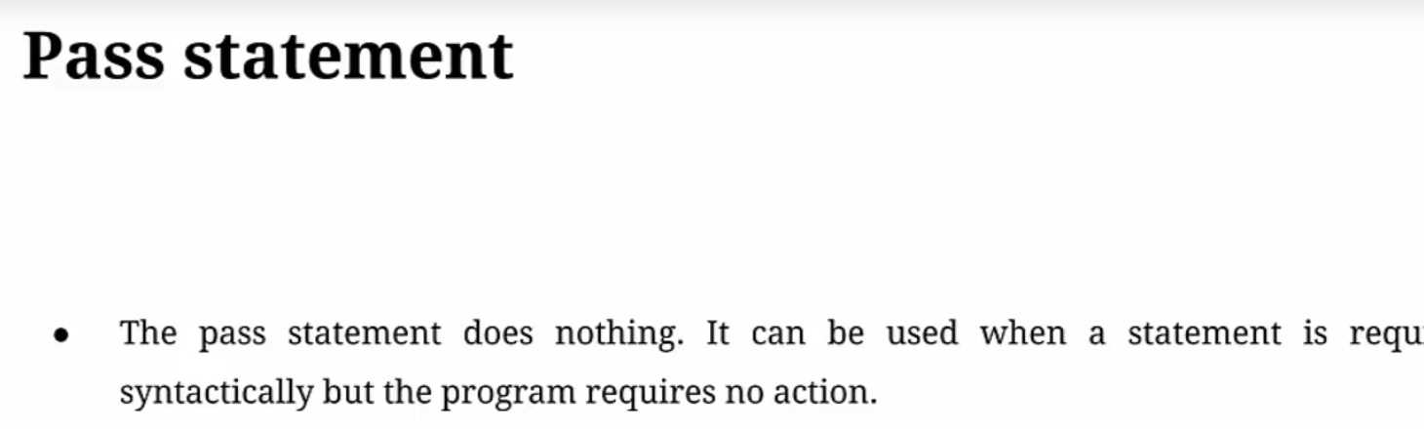

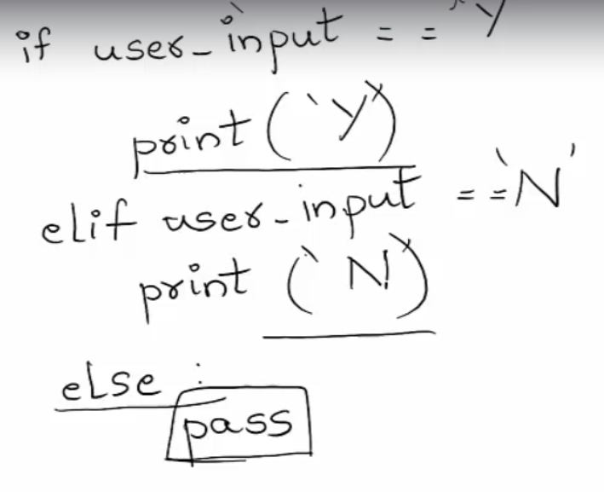

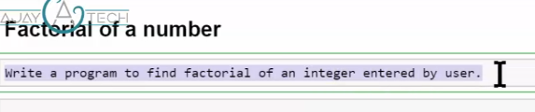

# Factorial of a number  
a = input('Please enter the number \n')  
a = int(a)  
fact = **1**if a == **0**:  
 print('The factorial of o is 1')  
elif a < **0**:  
 print('Sorry, factorial does not exist for negative numbers')  
else:  
 for i in range(**1,** a+**1**):  
 fact = fact*i  
 print("The factorial of"**,** a**,** "is"**,** fact)

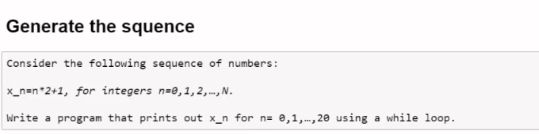

***\*\* 17. User Defined Function?***

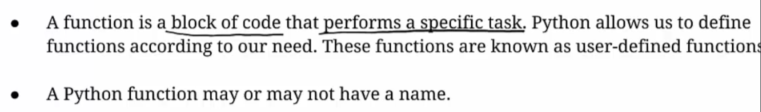

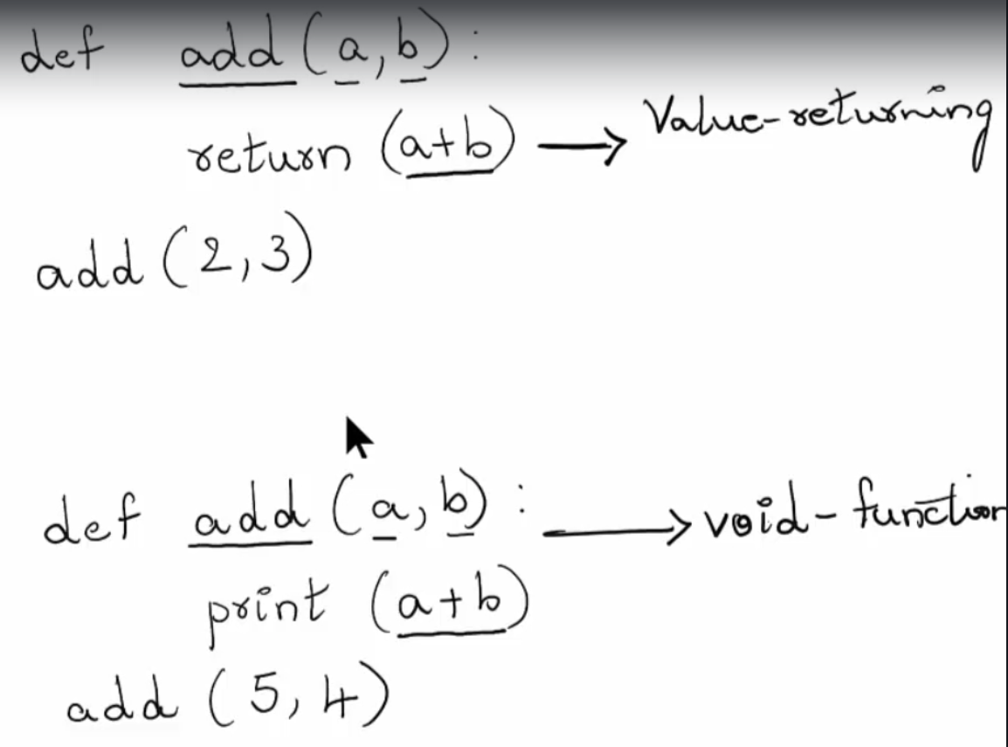

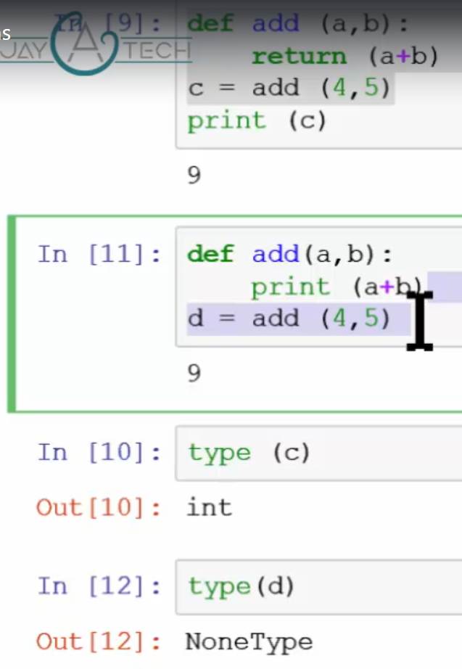

Function itself pass as an argument Value returning function Vs Void Function

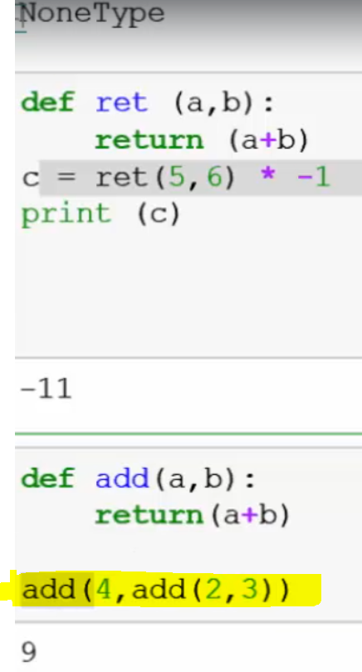 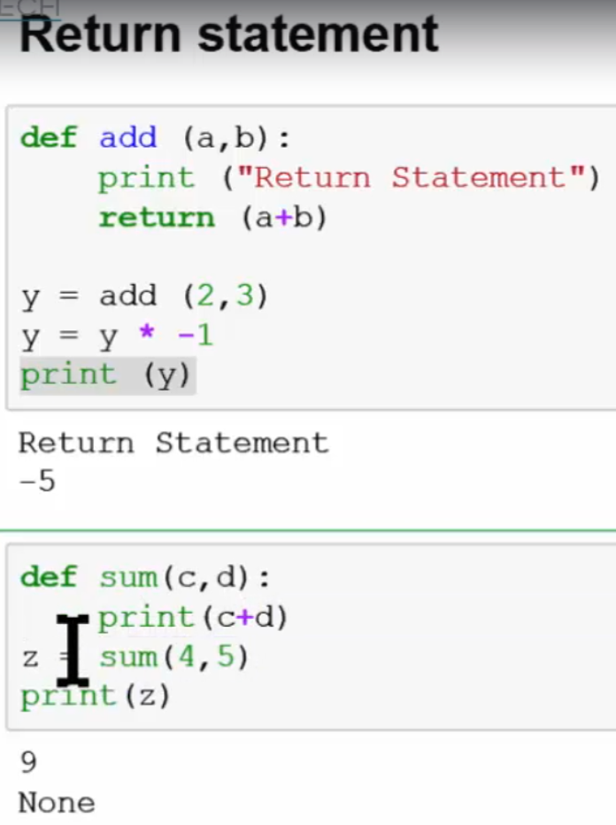

Function can return multiple values at a time

# Return multiple value from a function  
def misc(a**,** b):  
 return (a + b**,** a - b**,** a * b)  
  
  
l**,** m**,** n = misc(**2, 3**)  
print(l**,** m**,** n)

Parameter Vs Argument

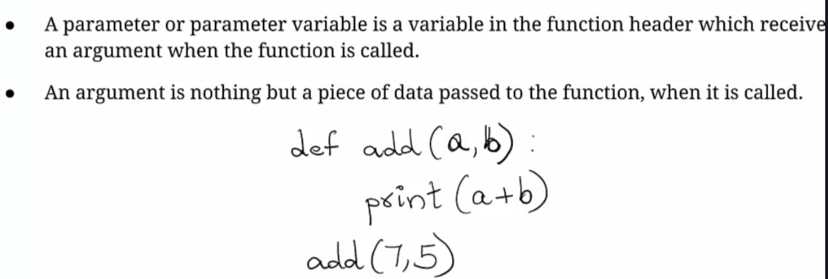

Different types of passing arguments

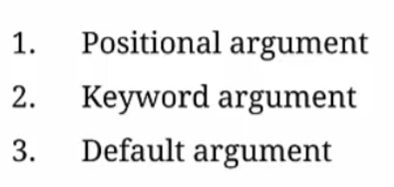

* 1. Argument must be in **same order**.

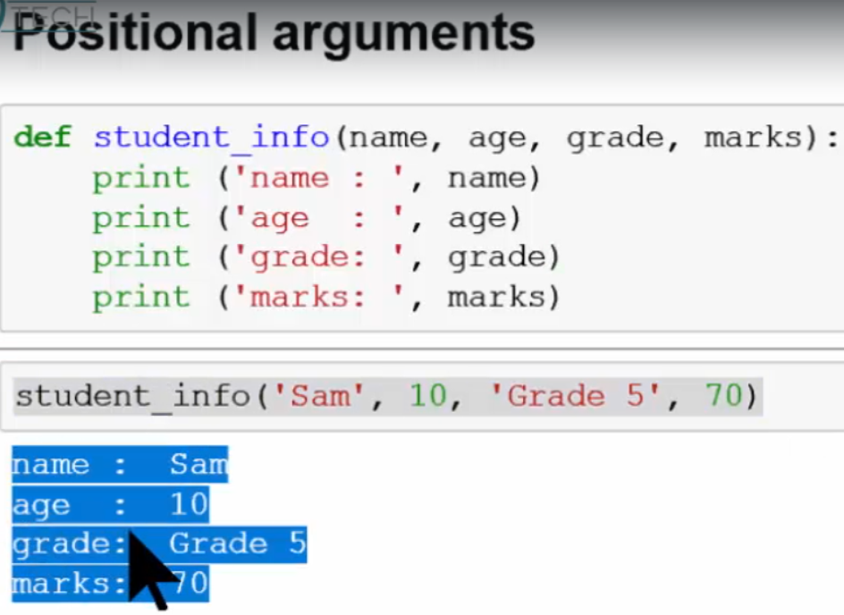

* 1. In key word argument **order of argument does not matter:**

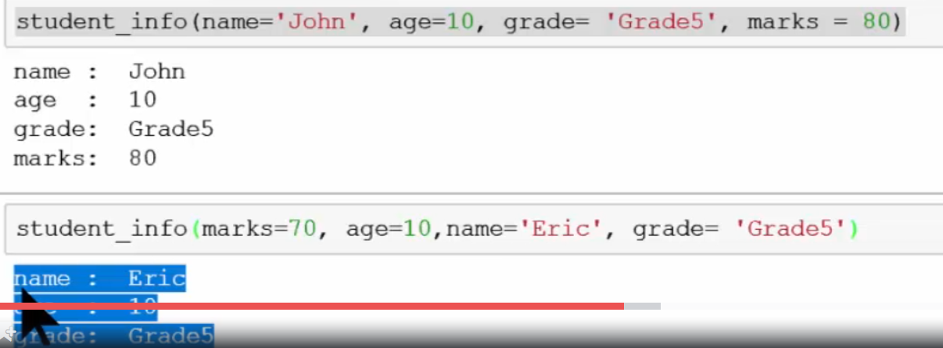

* 1. Default argument within function values are define.

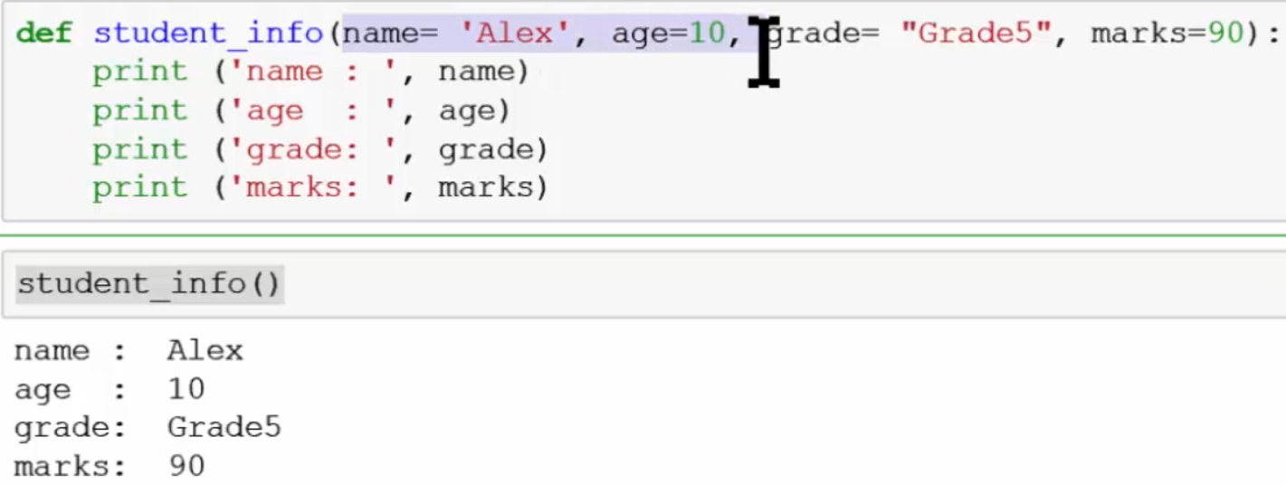

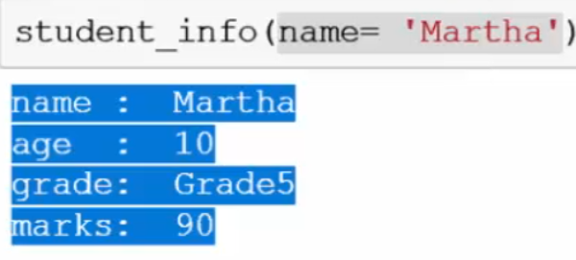

In Combine positional argument and key word argument, positional argument must be **appear before** keyword argument.

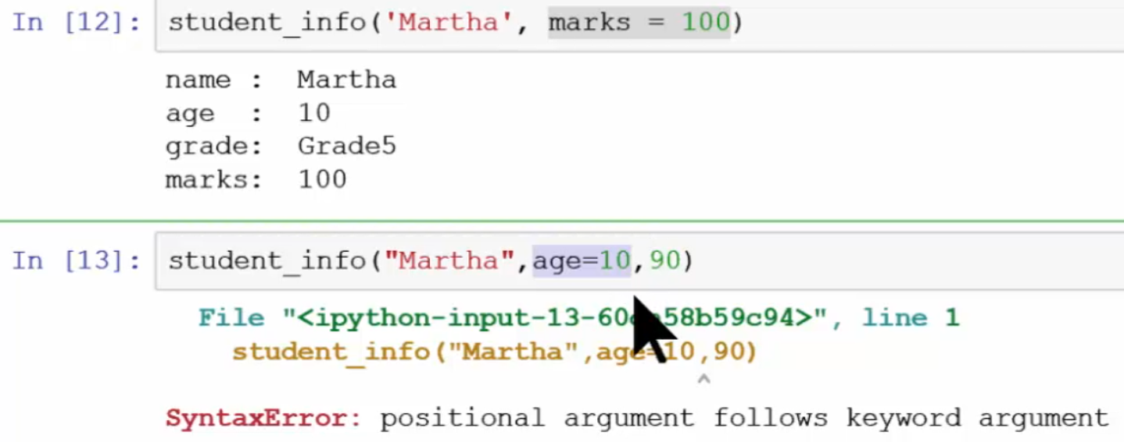

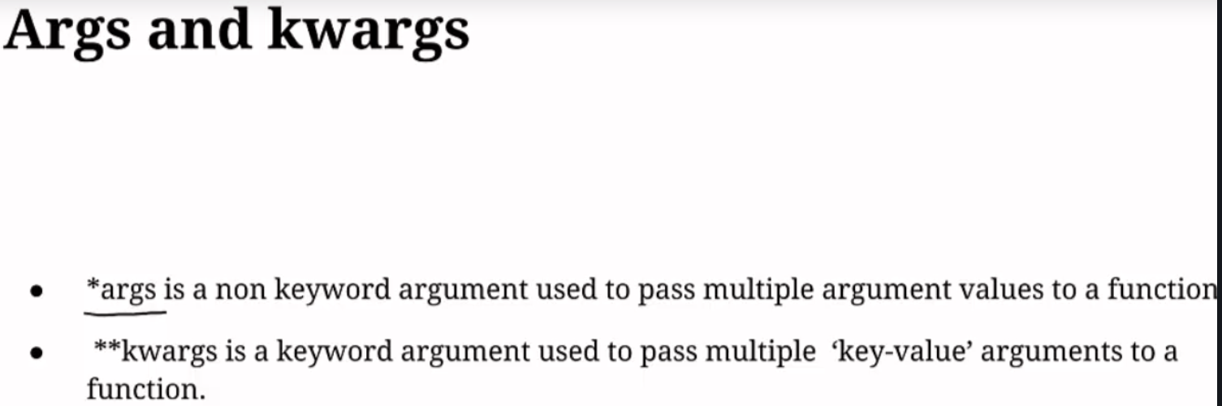

Non positional arguments:

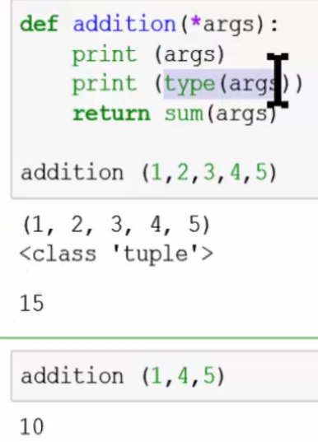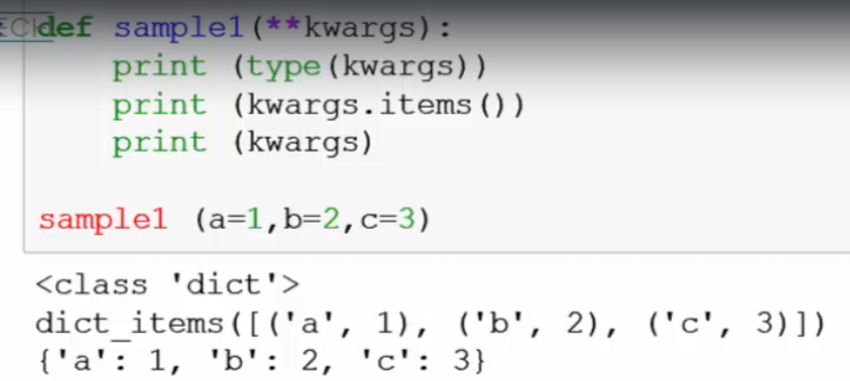

Positional arguments

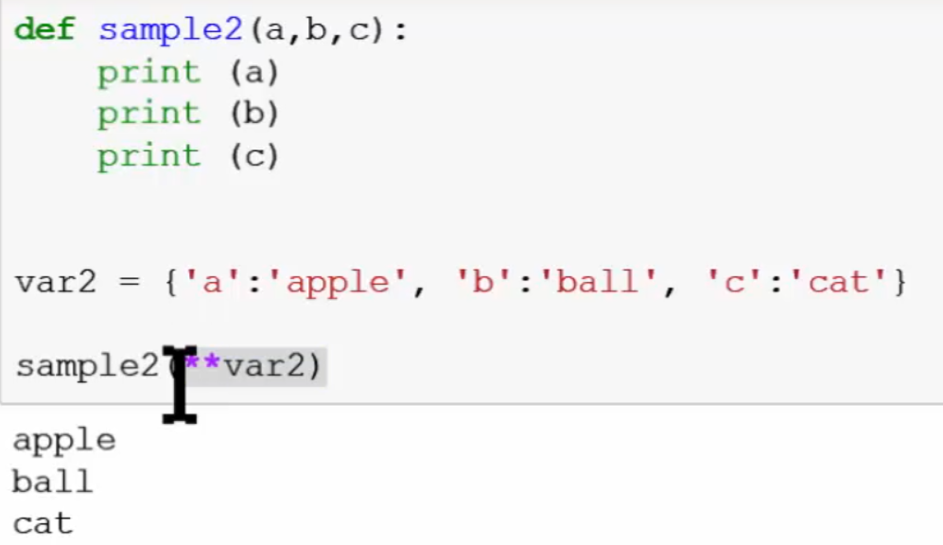 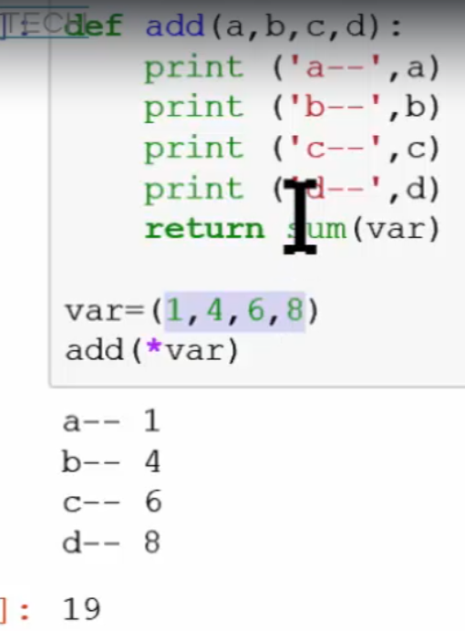

Combining of all arguments

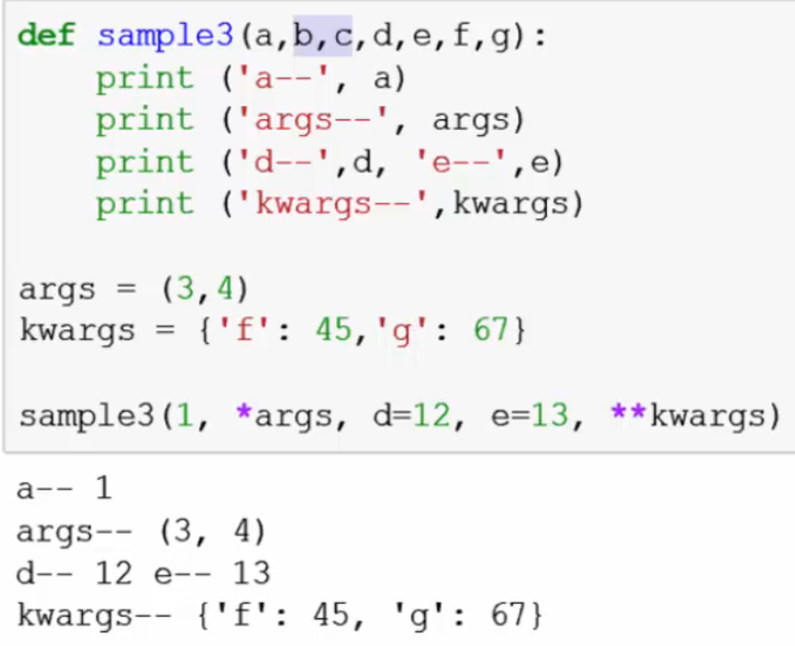

* **\*\* Lambda Function**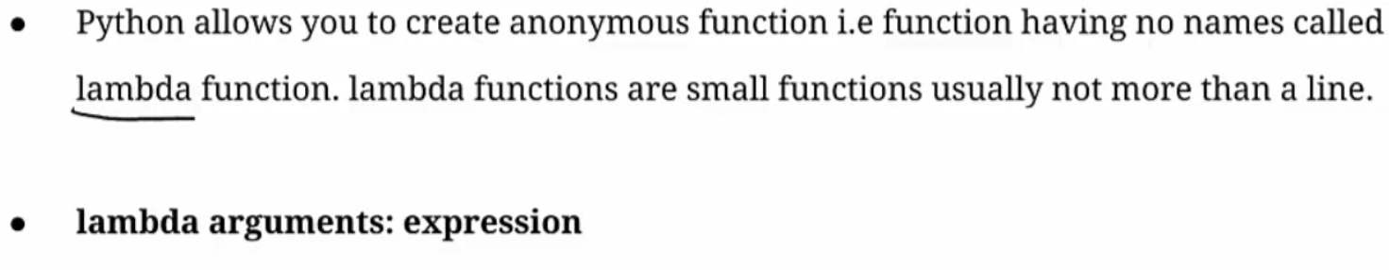

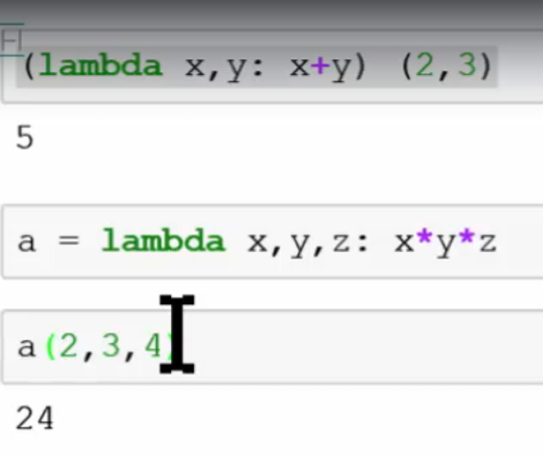

Lambda function can be used with the following built in function

**Map():-**

**Reduce():-**

**Filter()**

***\*\* 18. Object Oriented Programming?***

Python supports

* + Procedural programming
  + Functional programming
  + Object oriented programming
    1. **Class & Objects**

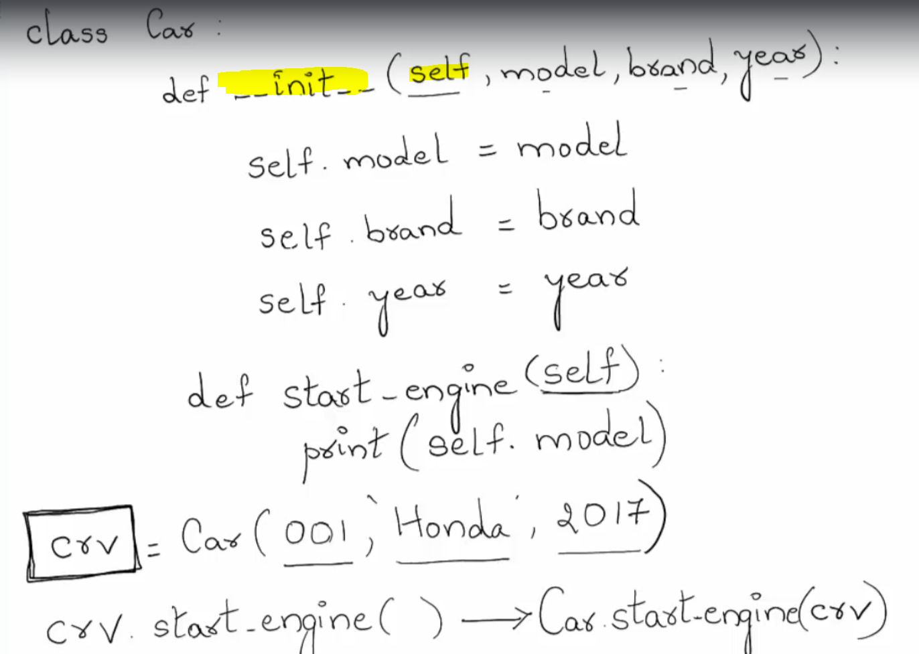

**__init__ :**

"__init__" is a reserved method in python classes. It is known as a **constructor** in object-oriented concepts. This method **called** when an **object is created** from the class and it allow the class to **initialize** the attributes of a class.

**Self:**

The word 'self' is used to represent the **instance** of a class means it refer the objects which is currently created. By using the "self" keyword we access the **attributes** and **methods** of the class in python.

Above example self.model is an instance variable and model used as a parameter in __init__ method.

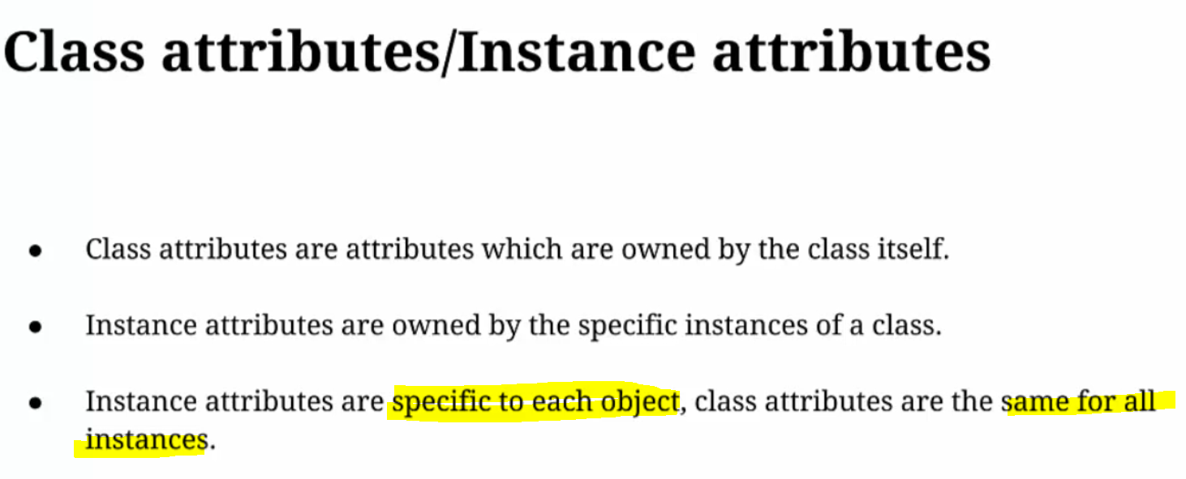

Class attributes are same for all instances of its class.

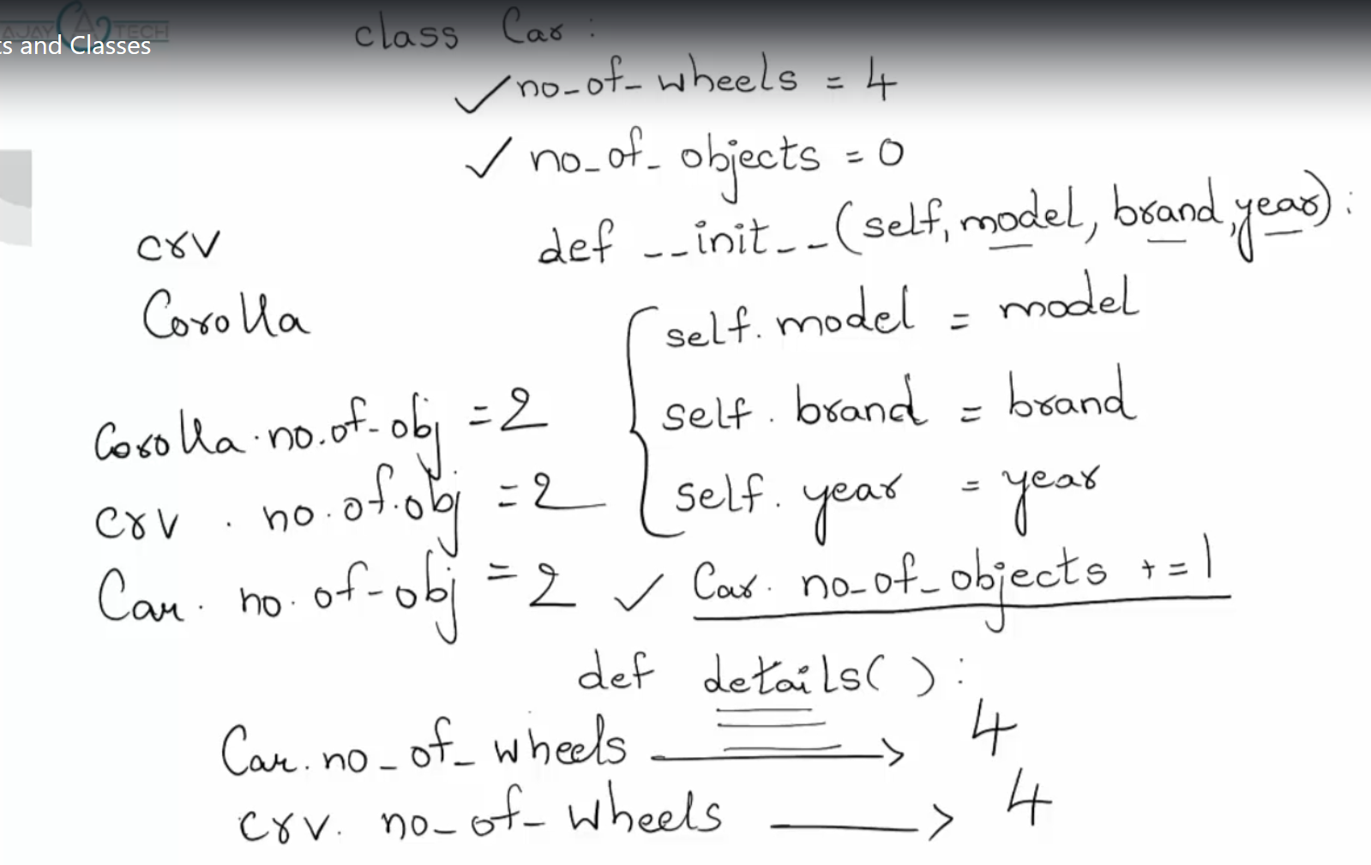

When object is created each time __init__ method gets call.

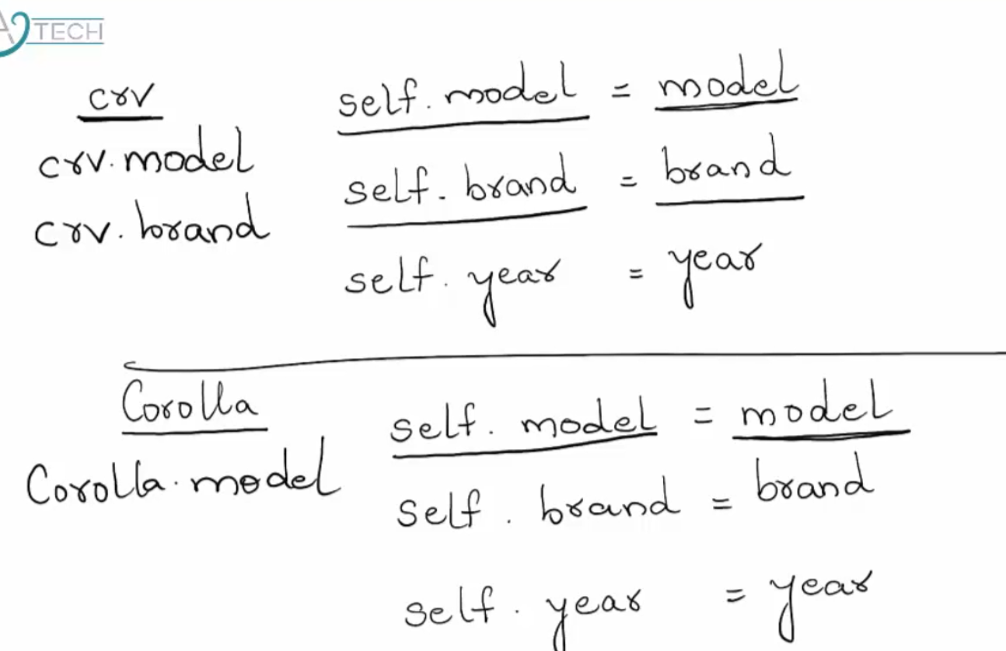

** **Class Structure:-**

# Define a class  
class Car:

*""" Documentation for class object """*  
 # define class attributes which are same for all instances.  
 no_of_wheels = **4** no_of_objects = **0** def __init__(self**,** model**,** brand**,** year):  
 # self.model = instance attribute & model is a parameter passed to the init method  
 self.model = model  
 self.brand = brand  
 self.year = year  
 # Class attribute is access by using class name followed by . operator.  
 # For every object it is going to increment by 1  
 Car.no_of_objects += **1** def start_engine(self):  
 print("Car engine is started")  
  
 # model,brand,year = instance attributes are global variable.  
 # global variable can be access through any method within a class.  
 def details(self):  
 print("Model: "**,** self.model)  
 print("Brand: "**,** self.brand)  
 print("Year: "**,** self.year)  
  
 # airbags = Local variable that can only access within emergency method.  
 def emergency(self**,** airbags):  
 if airbags:  
 print("Deploy airbags")  
  
  
# creating object  
# Python automatically passes object as a first argument into __init__ method  
obj = Car('001'**,** 'BMW'**, 2020**)  
print(obj.brand)  
# create another instance  
obj1 = Car('002'**,** 'AUDI'**, 2017**)  
# Class attributes are share for all its instances  
print(Car.no_of_objects)  
print(obj.no_of_wheels)  
print(obj1.no_of_wheels)  
# Now execute class methods for each object  
obj.start_engine()  
obj.details()  
obj.emergency(airbags=True)  
obj1.start_engine()  
obj1.details()  
obj1.emergency(airbags=False)

* **dir(Class name):**

It returns no of magic methods and its attribute within its class.

* __doc__:- display documentation string.
* __dict__: display corresponding attributers and its value.

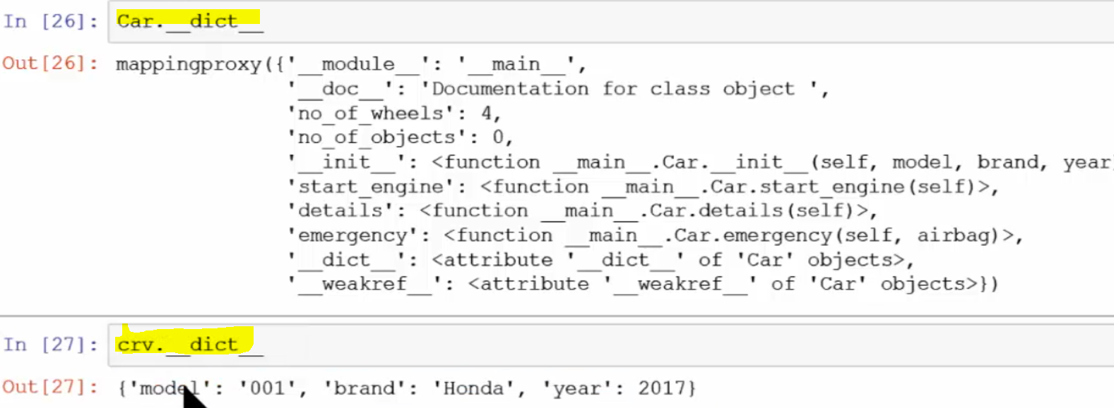

* + 1. **Inheritance:-**

It is the technique to inherit the features of an existing class to new classes.

Features included its different attributes and behavioral methods.

**Super ()**: it returns object as an instance of parent class.

Inheritance **support Method Overriding:-**

It overrides the method under the domain of child class, provided by its parent class.

If we want to access the overridden method inside child class, we can call it through **super ()** method.

class School:  
 *""" Documentation for class inheritance """* def __init__(self**,** school_name**,** location):  
 # initialise attributes  
 self.school_name = school_name  
 self.location = location  
  
 def details(self):  
 print("School Name is: "**,** self.school_name)  
 print("Location is: "**,** self.location)  
  
  
# child class Teacher inherit parent class School  
class Teacher(School):  
 def __init__(self**,** tname**,** subject**,** school_name**,** location):  
 self.tname = tname  
 self.subject = subject  
 # directly call __init__() of parent class  
 # return object as an instance of parent class  
 super().__init__(school_name**,** location)  
  
# Overridding details() in child class  
 def details(self):  
 print("Teacher Name is: "**,** self.tname)  
 print("Subject is: "**,** self.subject)  
 # access overridden method using super()  
 super().details()

abc = School('ABC School'**,** 'Kolkata')  
abc.details()

cde = Teacher('ABC School'**,** 'Kolkata'**,** 'Jemkin'**,** 'Mathematics')  
cde.details()

School Name is: ABC School

Location is: Kolkata

Teacher Name is: ABC School

Subject is: Kolkata

School Name is: Jemkin

Location is: Mathematics

* + 1. **Object:-**

Everything in python is an object which is an entity that contain with data called attributes and associated functions called method.

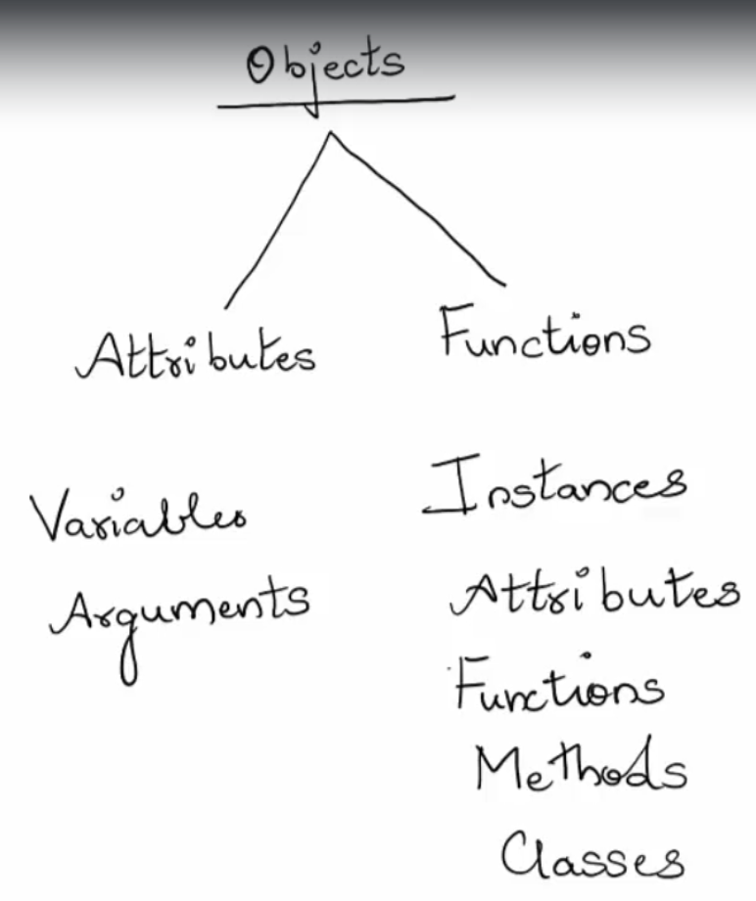

* + 1. **Polymorphism:-**

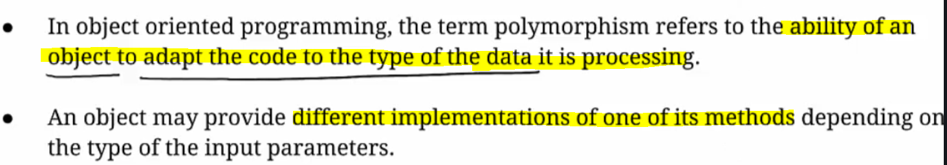

* + 1. **Encapsulation:-**

It is a concept that binds together the data and function which manipulate the data that keeps both safe from outside interference and misuse.

It also prevents unauthorized access to them and safe storage of data.

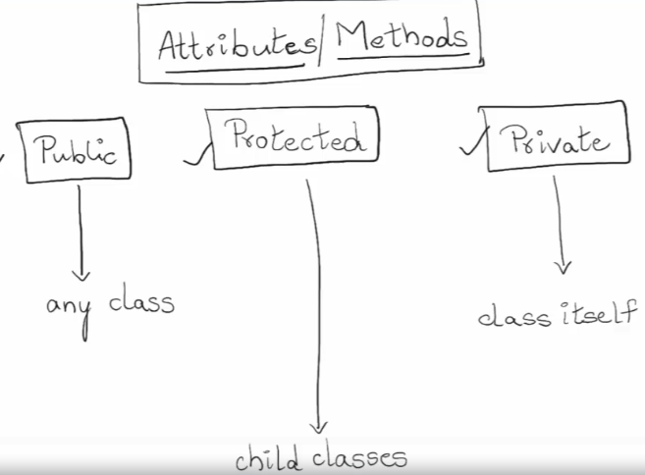

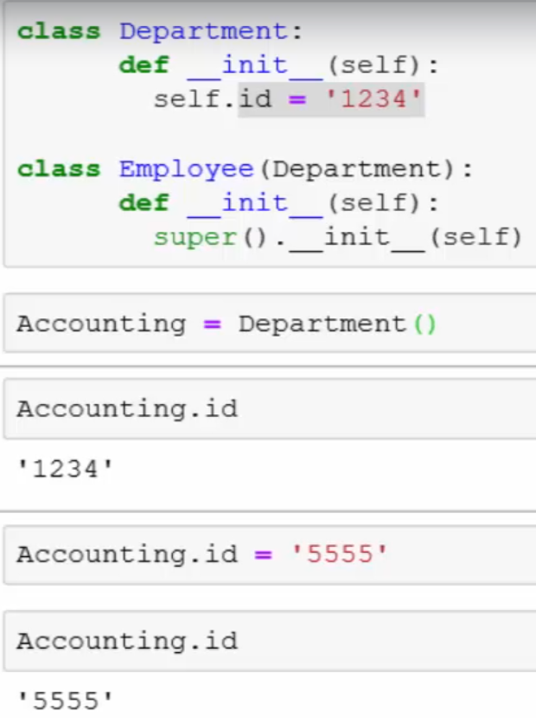

**Difference between str() and repr():-**

**str() is used for creating output for end user while repr() is mainly used for debugging and development. repr’s goal is to be unambiguous and str’s is to be readable**. For example, if we suspect a float has a small rounding error, repr will show us while str may not.

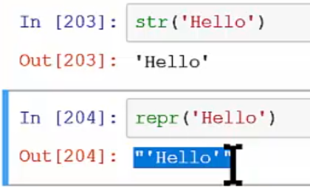

***19. Package Management System?***

Some of the important directory folders and subdirectory

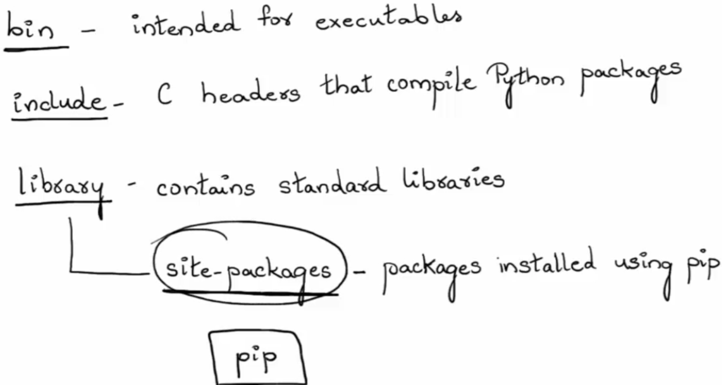

**Virtual Environment:**

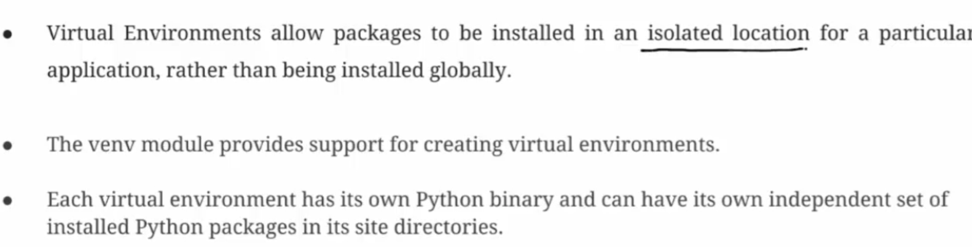

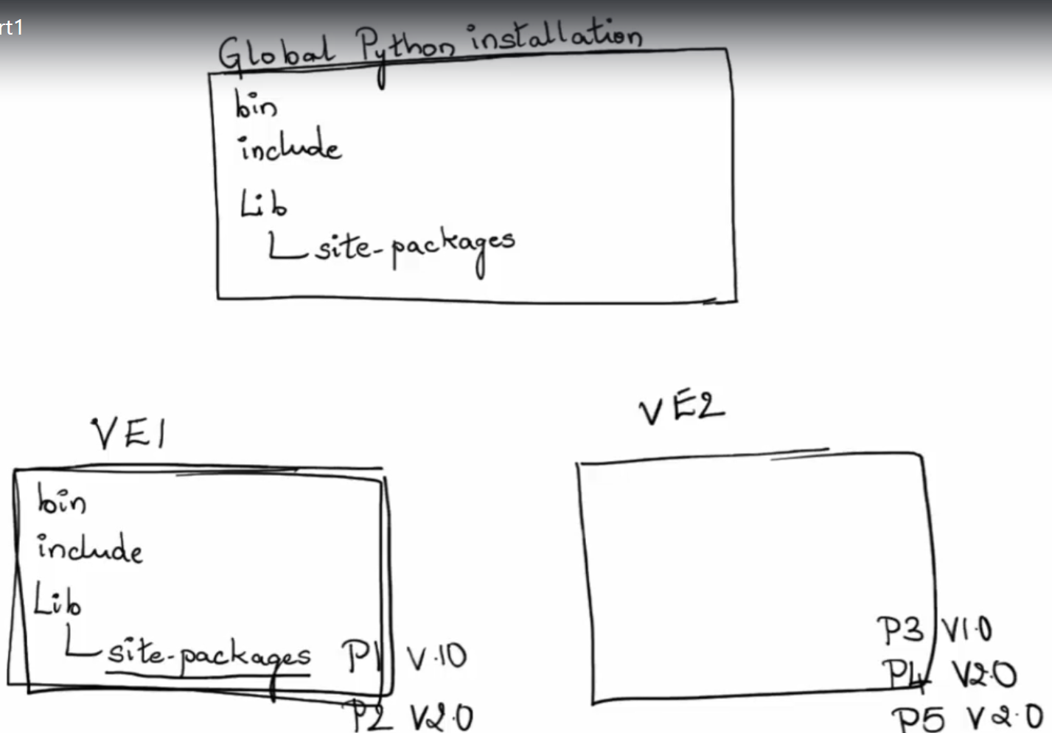

***20. Modules and Packages?***

***21. Error and Exceptions?***

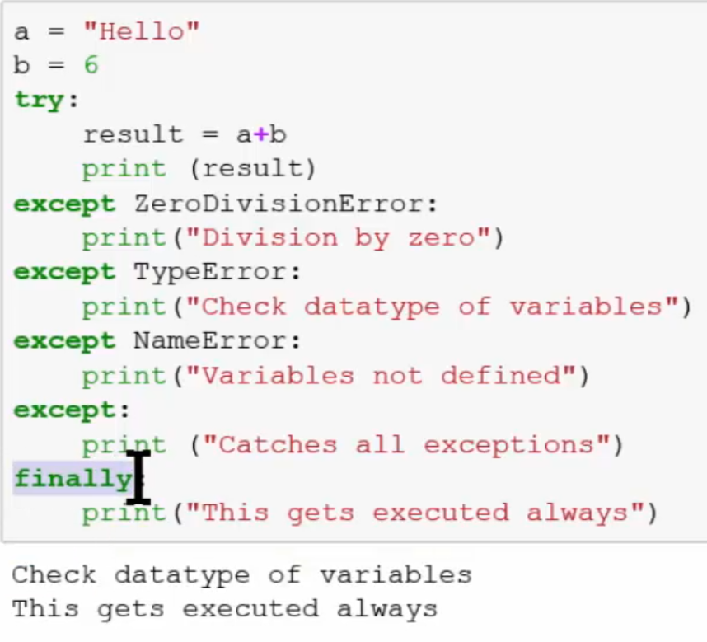

1. Please write an example of a print function.
2. Considering the following code:  s = 'catandapple'  | Write an expression that evaluate to 'apple'.
3. s1 = 'catandapple' a start with 7th position  
   print(s1[**6**:])
4. Define “slicing”.

A slice object is used to specify how to slice a sequence. You can specify where to start the slicing, and where to end. You can also specify the step, which allows you to e.g. slice only every other item.

1. Define “docstring”
2. How do you copy an object in Python?
3. What is the difference between “Xrange” and “range”?
4. What is the starting point of Python code execution?
5. What is the output of print str[4: ] if str = ‘ Python Language’? on Language

***22. What is the difference between Python Arrays and lists?***

***Ans:*** Arrays and lists, in Python, have the same way of storing data. But **arrays** can hold **only a single data type** element whereas lists can hold any data type elements.

***23. What is __init__?***

***Ans:***__init__ is a method or **constructor** in [Python](https://www.edureka.co/blog/python-programming-language). This method is **automatically** called to allocate memory when a new **object/ instance of a class is created**. All classes have the __init__ method.

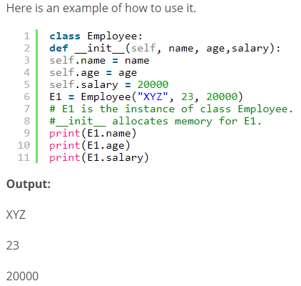

***24. What is lambda Function?***

***Ans:***An anonymous function is known as a lambda function. This function can have any number of parameters but can have just one statement.

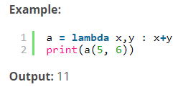

***25. What is self in Python?***

***Ans:***Self is an **instance** or an **object** of a class. In Python, this is **explicitly** included as the **first** parameter. It helps to **differentiate** between the **methods** and **attributes** of a class with local variables.

The self-variable in the init method refers to the newly created object while in other methods, it refers to the object whose method was called.

***26. How does break, continue and pass work?***

|  |  |
| --- | --- |
| Break | Allows loop termination when some condition is met, and the control is transferred to the **next** statement. |
| Continue | Allows skipping some part of a loop when some specific condition is met, and the control is transferred to the **beginning of the loop** |
| Pass | Used when you need some block of code syntactically, but you want to skip its execution. This is basically a **null** operation. **Nothing happens** when this is executed. |

***27. What does [::-1} do?***

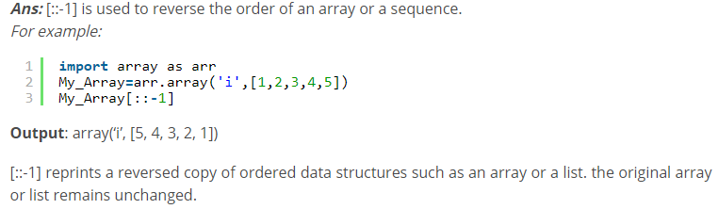

***28. What is the difference between range & xrange?***

They both provide a way to **generate a list of integers** for you to use.

* The only difference is that **range** returns a **Python list object** and x range returns an **xrange object**.
* The variable storing the**range** created by range() **takes more memory** as compared to variable storing the range using xrange(). The basic reason for this is the return type of range() is list and xrange() is xrange() object.
* As range() returns the **list**, all the operations(Like slice, Indexing etc.) that **can** be applied on the list can be used on it. On the other hand, as xrange() returns the xrange object, operations associated to list **cannot** be applied on them, hence a disadvantage.
* **xrange** is**faster** in implementation than range().

***29.*** ***What is pickling and unpickling?***

**Ans:** Pickle module accepts any Python object and converts it into a **string representation** and **dumps it into a file** by using dump function, this process is called **pickling**. While the process **of retrieving original Python objects** from the stored string representation is called unpickling.

***30.*** ***What is iterators?***

***Ans:***Iterators are objects which can be **traversed though** or iterated upon.

In Python, iterators are used to iterate a group of elements, containers like a list. Iterators are the collection of items, and it can be a list, tuple, or a dictionary. Python iterator implements **__itr__** and **next()** method to iterate the stored elements. In Python, we generally use loops to iterate over the collections (list, tuple).

***31.*** ***What is generators?***

***Ans:***Functions that return an inerrable set of items are called generators.

In Python, the generator is a way that **specifies how to implement iterators**. It is a normal function except that it yields expression in the function. It **does not implements** __itr__ and next() method and reduce other overheads as well.

If a function contains at least a yield statement, it becomes a generator. The yield keyword pauses the current execution by saving its states and then resume from the same when required.

***32.*** ***What are docstrings in Python?***

***Ans:***Docstrings are not actually comments, but they are **documentation strings**. These docstrings are within triple quotes. They are not assigned to any variable and therefore, at times, serve the purpose of comments as well.

***33. What is the usage of help() and dir() function in Python?***

**Ans:** Help() and dir() both functions are accessible from the Python interpreter and used for viewing a consolidated dump of built-in functions.

1. Help() function: The help() function is used to display the **documentation string** and also facilitates you to see the help related to modules, keywords, attributes, etc.
2. Dir() function: The dir() function is used to **display** the **defined symbols.**

***34. What does this mean: *args, **kwargs? And why would we use it?***

**Ans:** We use *args when we **aren’t sure** **how many arguments** are going to be passed to a function, or if we want to pass a stored list or tuple of arguments to a function.

**kwargs is used when we don’t know **how many keyword arguments** will be passed to a function, or it can be used to pass the values of a dictionary as keyword arguments.

The identifiers args and kwargs are a convention, you could also use *bob and **billy but that would not be wise.

***35. What do you mean by Python literals?***

Literals can be defined as a data which is given in a variable or constant. Python supports the following literals:

**String Literals**

**Numeric Literals**

**Boolean Literals**

***36. How to overload constructors or methods in Python?***

Python's constructor: _init__ () is the first method of a class. Whenever we try to instantiate an object __init__() is automatically invoked by python to initialize members of an object. We **can't overload constructors or methods in Python**. It shows an error if we try to overload.

**class** student:

**def** __init__(self,name):

        self.name = name

**def** __init__(self, name, email):

        self.name = name

        self.email = email

# This line will generate an error

#st = student("rahul")

# This line will call the second constructor

st = student("rahul", "rahul@gmail.com")

**print**(st.name)

Output:

rahul

***37. What is the difference between remove() function and del statement?***

You can use the remove() function to **delete a specific object in the list**. If you want to delete an object at a **specific location (index) in the list**, you can either use del or pop.

***38. What is swapcase() function in the Python?***

It is a string's function which converts all uppercase characters into lowercase and vice versa.

***39. How to remove whitespaces from a string in Python?***

To remove the whitespaces and trailing spaces from the string, Python provides **strip([str])** built-in function.

***40. What is the Python decorator & Closure?***

Decorators are very powerful and a useful tool in Python that allows the programmers to **modify the behavior of any class or function** without modifying its structure.

In Decorators, functions are taken as the **argument(inbuilt, Custom function as well)** into another function and then called **inside the wrapper function**.

**Functions vs. Decorators**

A function is a block of code that performs a specific task whereas a decorator is a function that **modifies other functions**.

Python **Closures** are these **inner functions that are enclosed within the outer function**. Closures can access variables present in the outer function scope. It can access these variables even after the outer function has completed its execution.

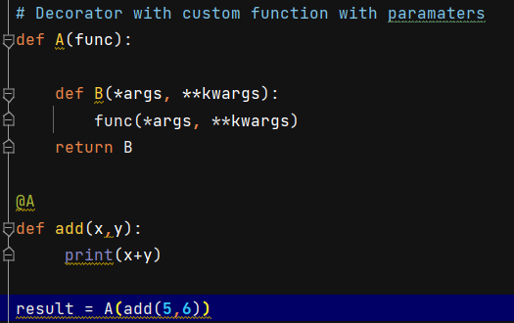

* + - 1. **Pass inbuilt function as a parameter**

*## Closures & initial Decorators*

**def** main_welcome(func):

**def** sub_welcome_class():

print("Welcome To Krish Naik Youtube Channel")

print(func([1,2,3,4,5,6]))

print("Please subscribe Krish channel")

**return** sub_welcome_class()

main_welcome(len)

Welcome To Krish Naik Youtube Channel

6

Please subscribe Krish channel

* + - 1. **Calling Decorator**

*### Decorators*

**def** main_welcome(func):

**def** sub_welcome_class():

print("Welcome To Krish Naik Youtube Channel")

func()

print("Please subscribe Krish channel")

**return** sub_welcome_class()

a=main_welcome(channel_name)

Welcome To Krish Naik Youtube Channel

This is Krish youtube channel

Please subscribe Krish channel

* + - 1. **Calling Decorator using decorator class**

@main_welcome

**def** channel_name():

print("This is Krish youtube channel")

Welcome To Krish Naik Youtube Channel

This is Krish youtube channel

Please subscribe Krish channel

***41) What is the namespace in Python?***

Python implements namespaces in the **form of dictionaries** and maintains name-to-object mapping where **names act as keys** and the **objects as values**.

***42) What is slicing in Python?***

Slicing is a mechanism used to **select a range of items from sequence type** like list, tuple, and string.

***43) What is the usage of enumerate () function in Python?***

The enumerate() function is used to iterate through the sequence and **retrieve the index position** and **its corresponding value** at the same time.

For i,v **in** enumerate(['Python','Java','C++']):

**print**(i,v)

0 Python

1 Java

2 C++

# enumerate using an index sequence

**for** count, item **in** enumerate(['Python','Java','C++'], 10):

***44) Give the output of this example: A[3] if A=[1,4,6,7,9,66,4,94].***

Since indexing starts from zero, an element present at 3rd index is 7. So, the output is 7.

***45) What will be the output of data[-2] from the list data = [1,5,8,6,9,3,4]?***

In the list, an element present at the 2nd index from the right is 3. So, the output will be 3.

***46) Deep Copy and Shallow Copy?***

Deep copy is a process in which the copying process occurs recursively. It means first constructing a **new collection object** and then recursively populating it with copies of the child objects found in the original. In case of deep copy, a copy of object is copied in other object. It means that **any changes** made to a copy of object **do not reflect** in the original object. In python, this is implemented using “**deepcopy()**” function.

A shallow copy means constructing **a new collection object** and then populating it with **references to the child objects** found in the original. The copying process **does not recurse** and therefore won’t create copies of the child objects themselves. In case of shallow copy, a reference of object is copied in other object. It means that **any changes** made to a copy of object **do reflect** in the original object. In python, this is implemented using “**copy()**” function.

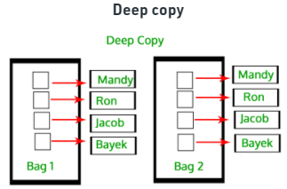 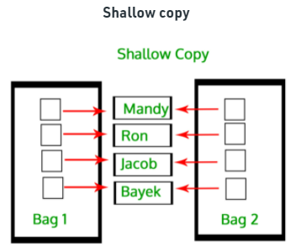

***47) What is the difference between a module and a package in Python?***

Each Python program file is a module that imports other modules like objects. Thus, a module is a way to **structure the program**. The **folder of a Python program** is called a package of modules.

***48) What is the range() function and what are its parameters?***

Only integer numbers are allowed, and hence, parameters can be both negative and positive.

range([start], stop[, step])

**Start**: gives the starting no. of the sequence

**Stop**: specifies the upper limit for the sequence

**Step**: is the incrementing factor in the sequence

***49) What is the use of %s?***

%s is a format specifier which transmutes **any value into a string**.

***50) What is GIL?***

GIL or the Global Interpreter Lock is a mutex, used to **limit access to Python objects**. It synchronizes threads and prevents them from running at the same time.

***51) Before the use of the ‘in’ operator, which method was used to check the presence of a key in a dictionary?***

The **has_key()** method

***52) How do you change the data type of a list?***

To change a list into a tuple, we use the tuple() function

To change it into a set, we use the set() function

To change it into a dictionary, we use the dict() function

To change it into a **string**, we use the **.join()** method

***53) Private & Protected?***

**Protected members**

Protected members (in C++ and JAVA) are those members of the class that cannot be accessed outside the class but can be accessed from **within the class and its subclasses**. To accomplish this in Python, just follow the convention by prefixing the name of the member by a **single underscore “_”.**

**Private members**

Private members are like protected members, the difference is that the class members declared private should **neither be** **accessed outside the class nor by any base class**. In Python, there is no existence of **Private**instance variables that cannot be accessed except inside a class. However, to define a private member prefix the member name with **double underscore “__”.**

***54) extend()  Method?***

The extend() method adds all the elements of an iterrable (list, tuple, string etc.) to the end of the list.

***55) Class method vs Static Method?***

* A class method takes **cls** as **first parameter** while a static method needs no specific parameters.
* A class method can **access or modify class state** while a static method can’t access or modify it.
* We use @classmethod decorator in python to create a class method and we use @staticmethod decorator to create a static method in python.

When to use what?

* We generally use class method to **create factory methods**. Factory methods **return class object** (**like a constructor**) for different use cases.
* We generally use static methods to ***create utility functions***.

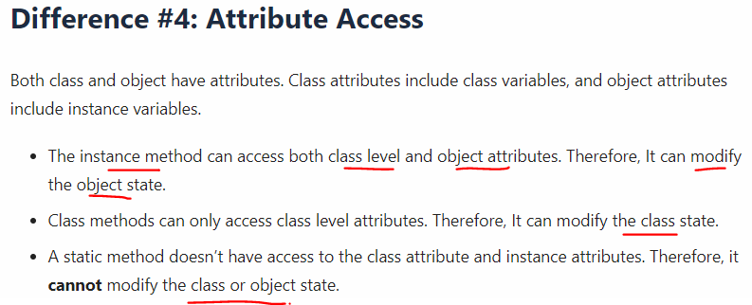

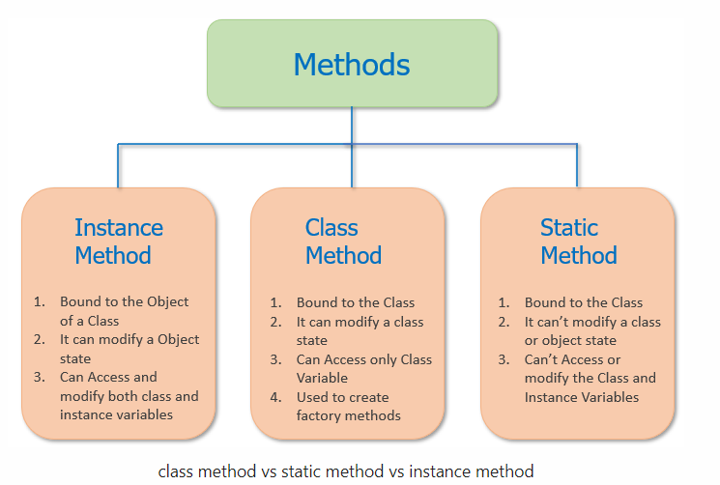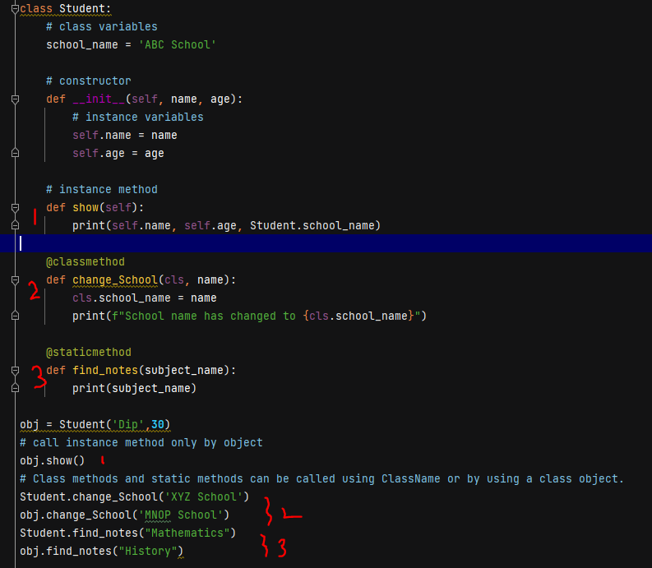

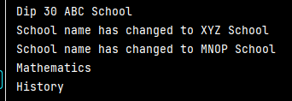

***56) What is Closure?***

The nested function was able to access the **non-local** (msg) **variable** of the enclosing function.

*### Closures*

**def** main_welcome(msg):

*# This is outer enclosing function*

**def** sub_welcome_class():

*# This is nested function*

print("Welcome To Krish Naik Youtube Channel")

print(msg)

print("Please subscribe Krish channel")

**return** sub_welcome_class()

main_welcome("Krish")

**The criteria that must be met to create closure in Python are summarized in the following points.**

* We must have a nested function (function inside a function).
* The nested function must refer to a value defined in the enclosing function.
* The enclosing function must return the nested function.

**When to use closures?**

* Closures can avoid the use of global values and provides some form of data hiding.

***57) What is DateTime module?***

Python has a module named **datetime** to work with dates and times.

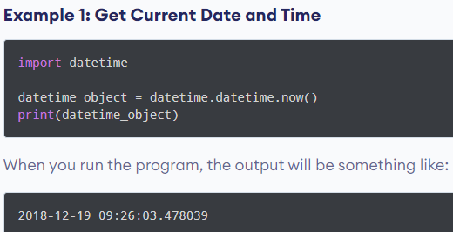 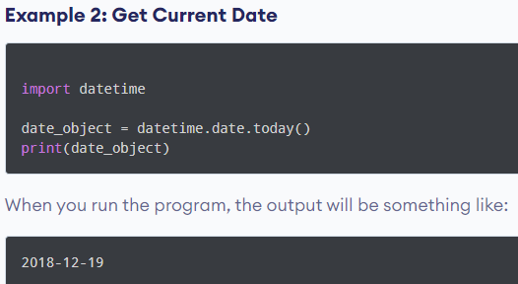

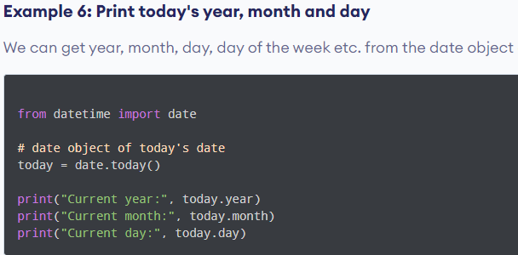

**Python strftime() - datetime object to string.**

**strptime() - datetime object to string.**

***57) Count Number of Characters in Text File?***

**Example 1: Count Characters in a Text File**

**Example 2: Count Characters in a Text File excluding spaces**

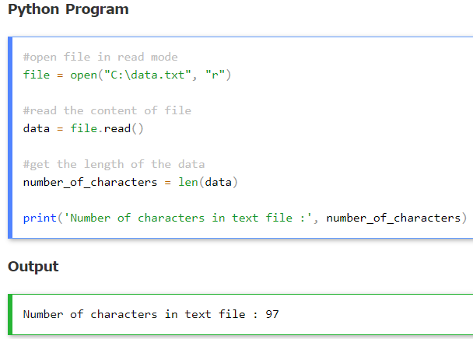

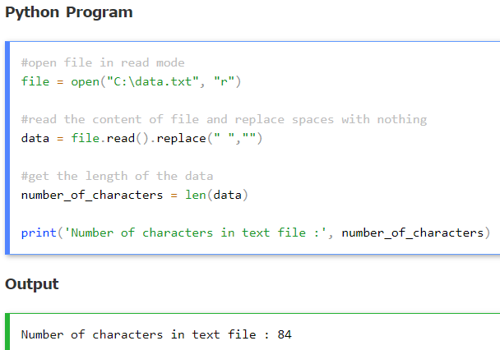

***58) Map(), Reduce(), Filter()?***

Generally, "map" means converting a **series of inputs to an equal length series of outputs** means **list of items** while "reduce" means converting a series of inputs into a smaller number of outputs or a **single item**.

reduce() isn't a built-in function anymore, and it can be found in the functools module.

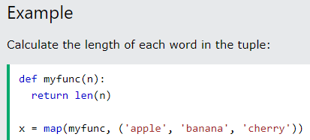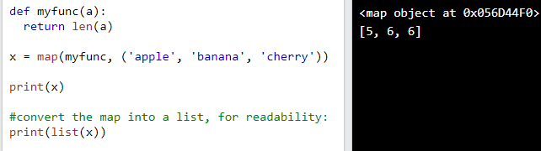

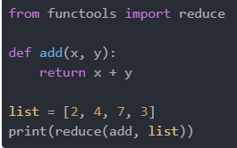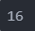

Similar to map(), filter() takes a function object and an inerrable and creates a new list. As the name suggests, filter() forms a new list that contains only elements that **satisfy a certain condition**, i.e. the function we passed returns True.

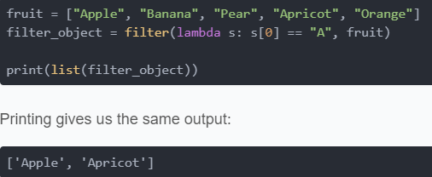

***58) Difference between Iterable & Iterator?***

***Iterable****is anything you can loop over with a for loop.*

*an****iterator****is an object which implements the****iterator****protocol, which consist of the methods iter() and next().*

*It is allocated memory* ***dynamically*** *while calling next() only.*

An object is called an iterable if u can get an iterator out of it.

1. Calling**iter()** function on an iterable gives us an iterator.
2. Calling **next()** function on iterator gives us the next element.
3. If the iterator is exhausted (if it has no more elements), calling next() raises **StopIteration**exception which is handled in for loop by default.

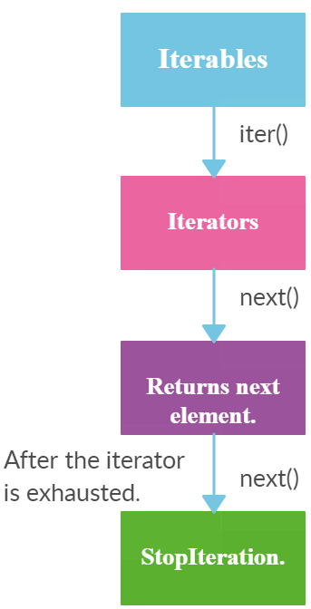

***59) Difference between Iterator & Generator?***

Python provides a generator to create your own [iterator function](https://www.tutorialsteacher.com/python/iter-method). A generator is a special type of function which does not return a single value, instead, **it returns an iterator object** with a sequence of values. In a generator function, a **yield** statement is used rather than a return statement.

def mygenerator():

print('First item')

yield 10

print('Second item')

yield 20

print('Last item')

yield 30

In the above example, the mygenerator() function is a generator function. It uses yield instead of return keyword. So, this will return the value against the yield keyword each time it is called. However, you need to create an iterator for this function, as shown below.

>>> gen = mygenerator()

>>> next(gen)

First item

10

>>> next(gen)

Second item

20

>>> next(gen)

Last item

30

The generator function cannot include the return keyword. If you include it, then it will terminate the function. The difference between yield and return is that yield returns a value and pauses the execution while maintaining the internal states, whereas the return statement returns a value and terminates the execution of the function.

The following generator function includes the return keyword.

def mygenerator():

print('First item')

yield 10

return

print('Second item')

yield 20

print('Last item')

yield 30

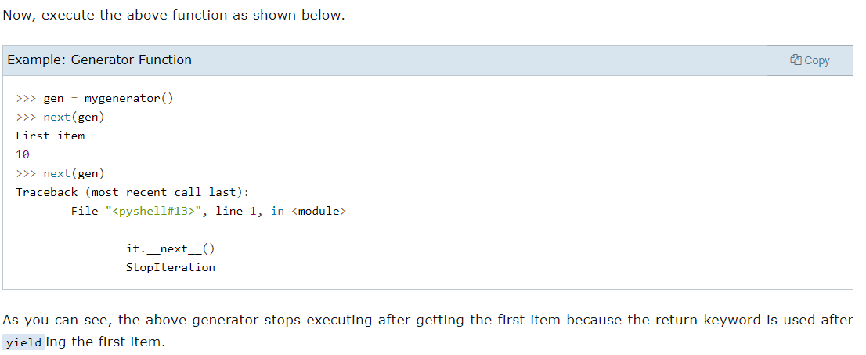

***60)*** ***How to check a key is exists in dictionary or not without through key error?***

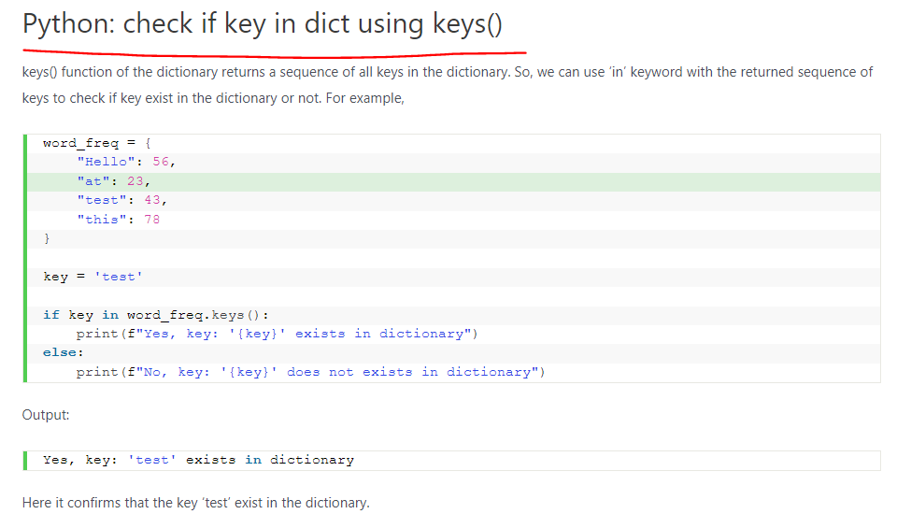

***61)Inheritance, Abstractions and Encapsulation?***

**Inheritance**

Inheritance is the capability of one class to derive or inherit the properties from another class. The class that derives properties is called the derived class or child class and the class from which the properties are being derived is called the base class or parent class. The benefits of inheritance are:

* It represents real-world relationships well.
* It provides the reusability of a code. We don’t have to write the same code again and again. Also, it allows us to **add more features to a class** **without modifying** it.
* It is **transitive** in nature, which means that if class B inherits from another class A, then all the subclasses of B would automatically inherit from class A.

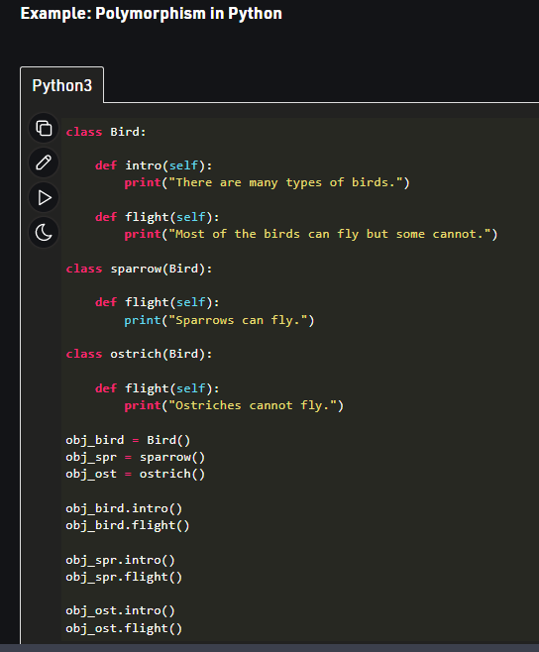 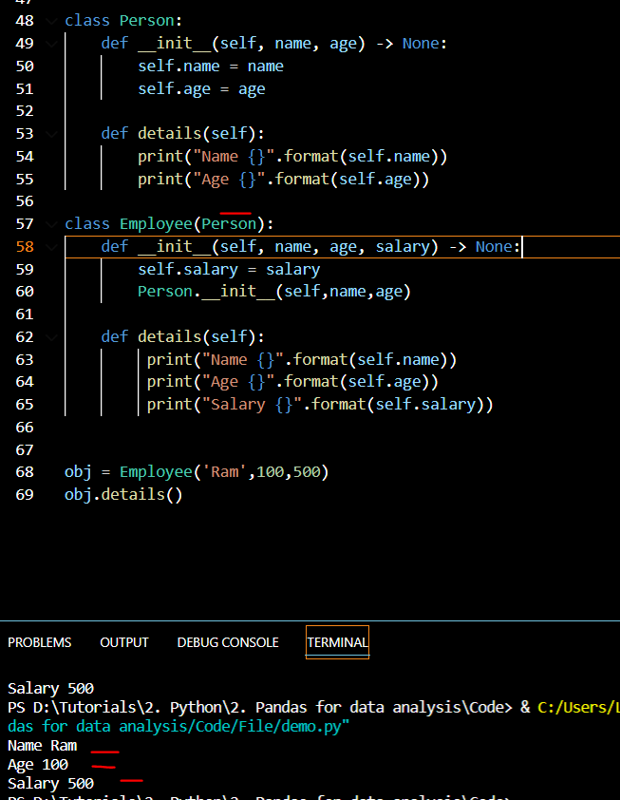**Single Inheritance:**

* Single inheritance enables a derived class to inherit properties from a single parent class, thus enabling code reusability and the addition of new features to existing code.

**Multiple Inheritance:**

* When a class can be derived from more than one base class this type of inheritance is called multiple inheritance. In multiple inheritance, all the features of the base classes are inherited into the derived class.

**Multilevel Inheritance**   
 In multilevel inheritance, features of the base class and the derived class are further inherited into the new derived class. This is similar to a relationship representing a child and grandfather.

**Hierarchical Inheritance:**

When more than one derived classes are created from a single base this type of inheritance is called hierarchical inheritance. In this program, we have a parent (base) class and two child (derived) classes.

**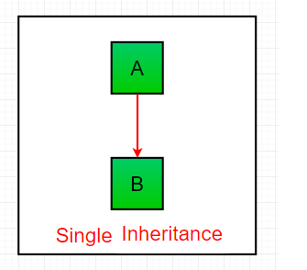 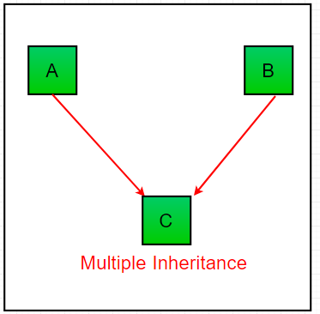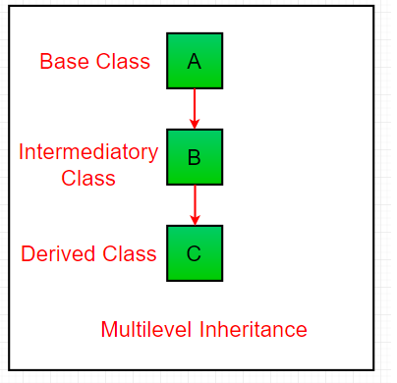**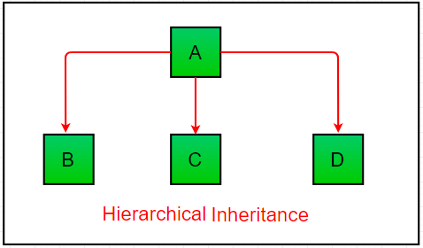

**Polymorphism**

* Polymorphism simply means having many forms. For example, we need to determine if the given species of birds fly or not, using polymorphism we can do this using a single function.

**Encapsulation**

This puts restrictions on accessing variables and methods directly and can prevent the accidental modification of data. To prevent accidental change, an object’s variable can only be changed by an object’s method. Those types of variables are known as private variables.

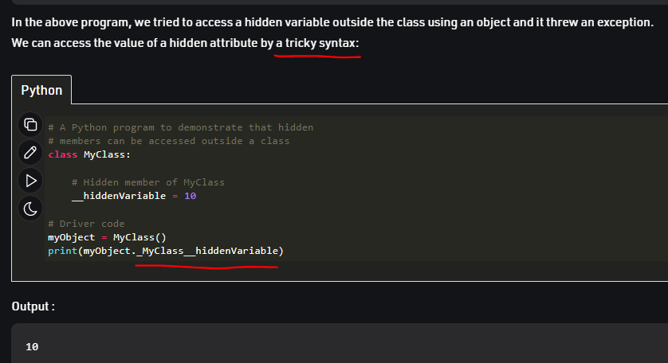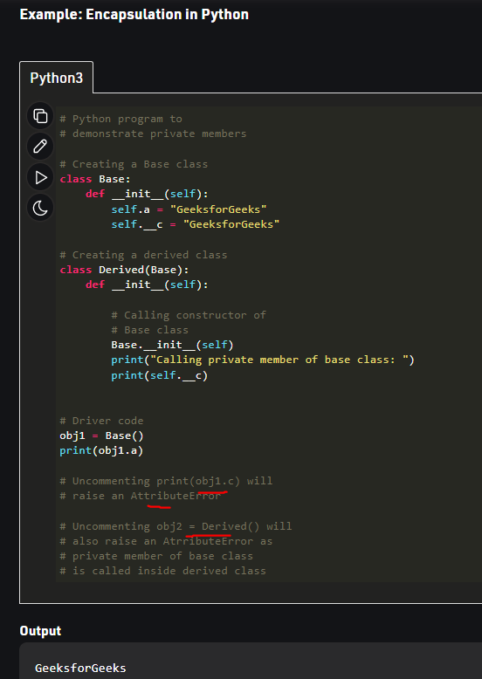

**How to check if a class is subclass of another?**

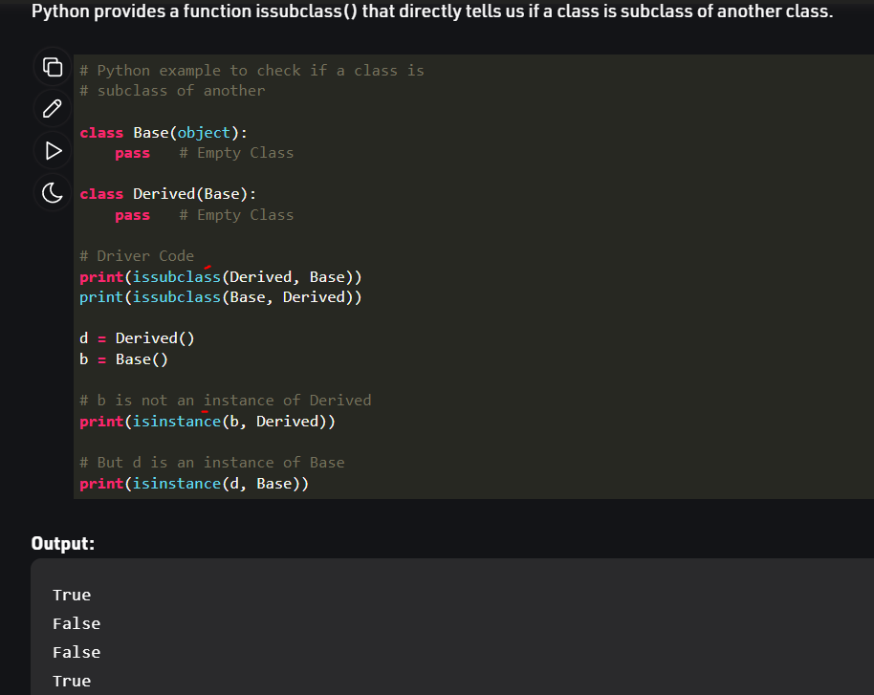

**How Abstract Base classes work :**By default, Python does not provide abstract classes. Python comes with a module **Abstract Base classes(ABC)** and that module name is ABC. ABC works by decorating methods of the base class as abstract and then registering concrete classes as implementations of the abstract base. A method becomes abstract when decorated with the keyword **@abstractmethod.**

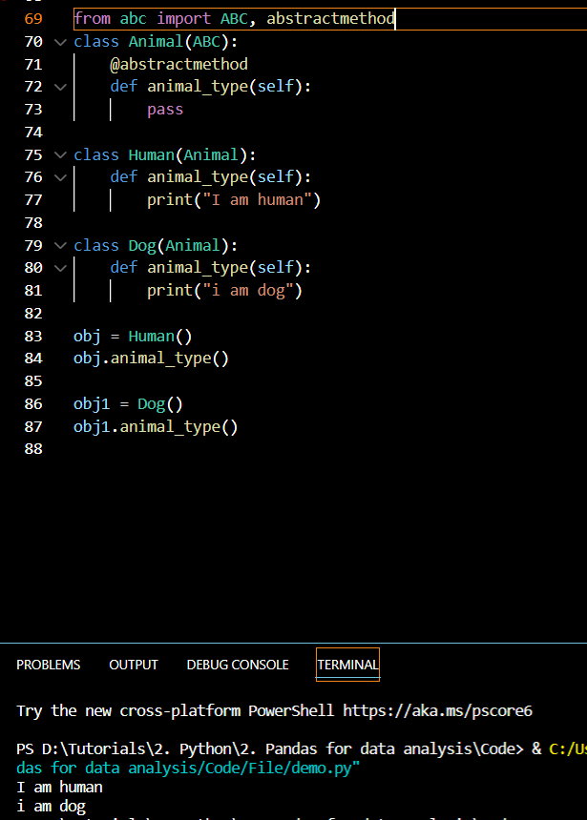

***62)*** ***Parallel Processing in Python?***

For parallelism, it is important to divide the problem into sub-units that do not depend on other sub-units (or less dependent).

There are two main ways to handle parallel programs:

* **Shared Memory**

In shared memory, the sub-units can communicate with each other through the same memory space.

* **Distributed memory**

In distributed memory, each process is totally separated and has its own memory space. In this scenario, communication is handled explicitly between the processes. Since the communication happens through a network interface, it is **costlier** compared to shared memory.

Due to **Global Interpreter Lock (GIL)** , threads can’t be used to increase performance in Python. GIL is a mechanism in which Python interpreter design **allow only one Python instruction to run at a time**. GIL limitation can be completely avoided by using **processes** instead of thread.

***63) How do you access parent members in the child class?***

**By using Parent class name:** You can use the name of the parent class to access the attributes.

**By using super():** The parent class members can be accessed in child class using the super keyword.

**Pandas Tutorial**

***1) Difference between loc() and iloc()?***

**loc** is label-based, which means that we must specify the **name** of the rows and columns that we need to filter out.

* Return type is series.
* # Selecting cars with brand 'Maruti' and Mileage > 25

print(df.loc[(df.Brand == 'Maruti') & (df.Mileage > 25)])

**iloc** is integer index based. So here, we must specify rows and columns by their **integer index**.

* Return type is a dataframe (Combination of many rows & columns).
* # Selecting range of rows from 2 to 5

print(df.iloc[2 : 5])

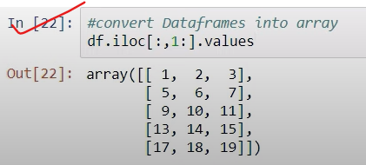

***2) check null for entire dataframe and individual column?***

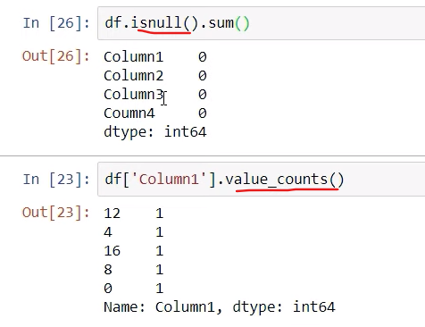

***3) Handle NULL & convert columns one data type to another?***

df.fillna():- df.replace():-

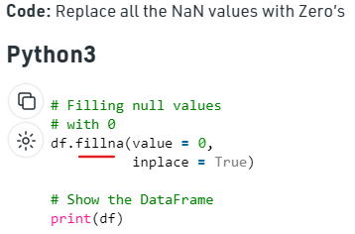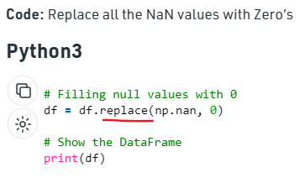

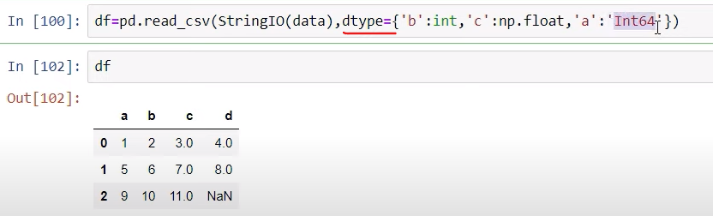

***4) Index column & select header column?***

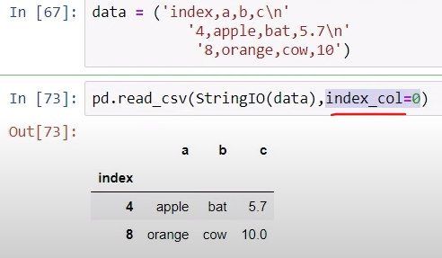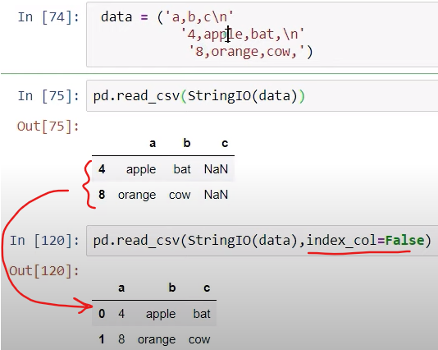

Make the same order of data without index using index_col = False.

***4) What is Pickling and Unpickling?***

Pickling allows you to save a python object as a **binary file on your hard drive**. After you pickle your object, you can kill your python session, reboot your computer if you want, and later load your object into python again.

**Unpickling** is the process of retrieving original python objects from the stored string representation i.e from the pickle file. It is the process of converting a byte stream into the python object.

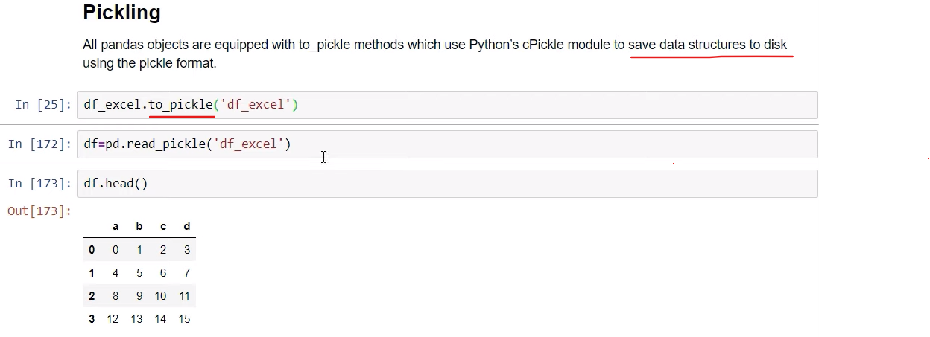

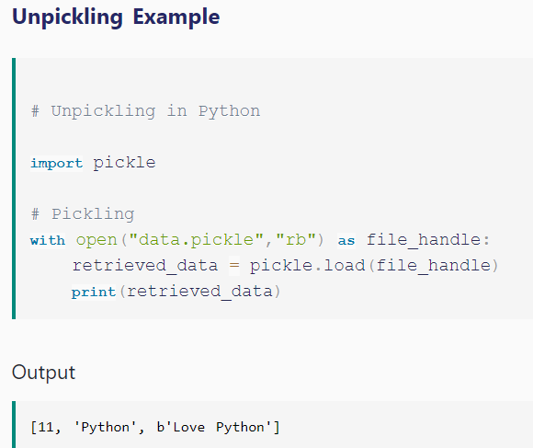

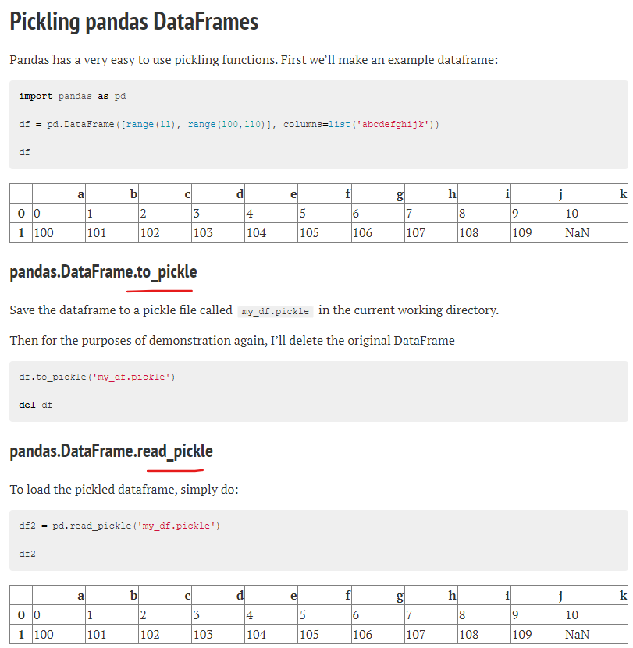

***5) How to convert a Data Frame to array?***

The function to_numpy() is used to convert the DataFrame to a NumPy array.

//syntaxDataFrame.to_numpy(self, dtype=None, copy=False)

The dtype parameter defines the data type to pass to the array and the copy ensures the returned value is not a view on another array.

***6)Add column in Data frame?***

<https://www.geeksforgeeks.org/adding-new-column-to-existing-dataframe-in-pandas/>

***6)SET_INDEX() in Data frame?***

<https://www.w3resource.com/pandas/dataframe/dataframe-set_index.php>

***7)* *Delete rows/columns from DataFrame using Pandas.drop()***

<https://www.geeksforgeeks.org/python-delete-rows-columns-from-dataframe-using-pandas-drop/>

***8)* *Sort dataframe using sort_index() & sort_values()?***

<https://www.kausalvikash.in/python-pandas-interview-questions-and-answers-for-freshers/>

**Numpy Tutorial**

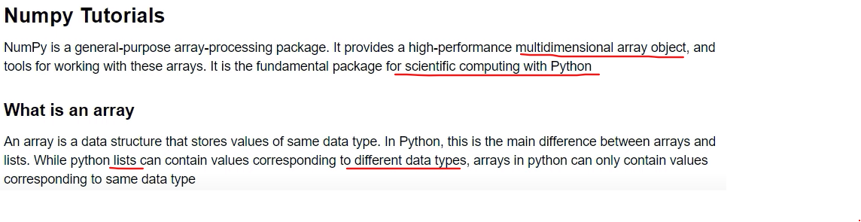

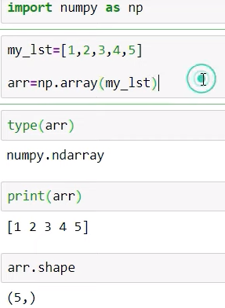 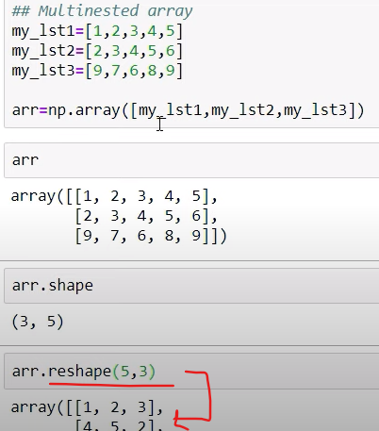 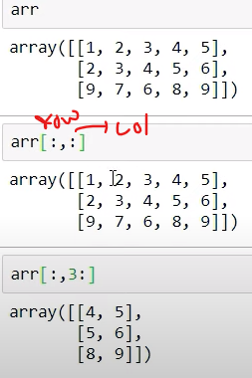 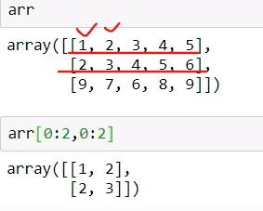

**Arrange():-**

**linspace():-** num= 50 between start and stop how many numbers are **equally divided**.

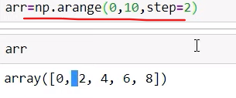 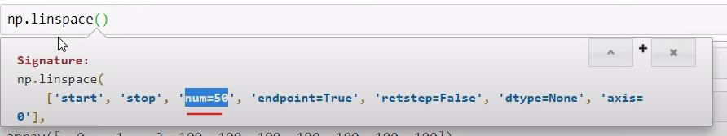 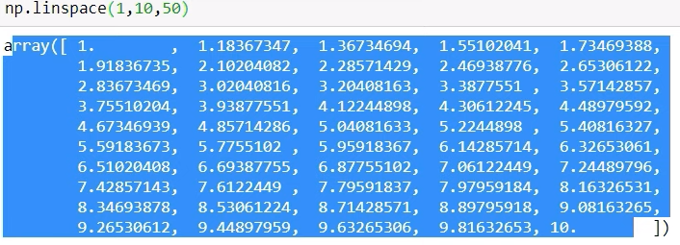

**copy():-** it create a new memory location so old value could not replace or overwrite.

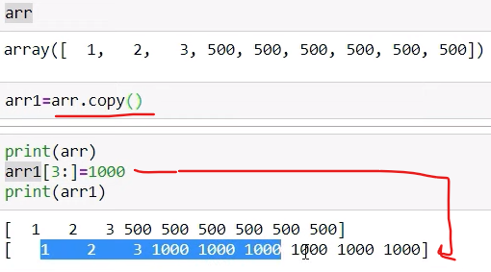

**Random distributions:-**

